Table of Contents

# Abstract

The question of whether occupational asbestos exposure is an under-recognized cause of idiopathic pulmonary fibrosis arises because it is clinically plausible, epidemiologically plausible, and consistent with fibre studies and case-control data. This thesis examines the question by means of a literature review and a novel hospital based case-control study, the idiopathic pulmonary fibrosis job exposures study (IPFJES).

# Acknowledgements

I am grateful to Zeinab, Ada, and Rosa for putting up with me.

I am grateful to Paul, Chris, and Sara for their supervision.

I am grateful to the participants, to Rupa, and to all of the principle investigators and their teams for helping to make the study happen.

# 

# List of tables

Table 5.1 This is an example table . . .   
Table x.x Short title of the figure . . .

To be added by Carl

# Abbreviations

* **IPF** Idiopathic pulmonary fibrosis.
* **MUC5B** Mucin 5B gene.
* **IPFJES** Idiopathic pulmonary fibrosis job exposures study.
* **JEM** Job exposure matrix.
* **mMRC dyspnoea score** Modified Medical Research Council dyspnoea score.
* **PMR** Proportional mortality rate.
* **ONS** Office for National Statistics.
* **SOC** Standard occupational classification.
* **NS-SEC** National Statistics Socio-economic Classification.
* **SNP** Single-nucleotide polymorphism.
* **PCR** Polymerase chain reaction.
* **GWAS** Genome wide association study.

# Introduction to thesis

## Occupational asbestos exposure as an under-recognised cause of idiopathic pulmonary fibrosis

Idiopathic pulmonary fibrosis (IPF) is a progressive, fibrotic lung disease which in 2016 was the recorded cause of death for approximately 5000 people in England and Wales. Its incidence, currently around 7.5/100,000 person-years, has increased by 5% per annum in the period 1979-2016.[1][2] The pathophysiology of IPF is complex, the outcome of host susceptibility factors, epithelial injury, and a dysregulated repair process. Several gene polymorphisms which result in a vulnerable alveolar epithelium have been characterized; they include abnormalities in mucin genes (eg MUC5B), surfactant protein genes, and telomerase genes (eg TERT and TERC).[3][4][5] The median age of onset is 70 years and the condition is more common in men (M:F ratio 1.6), manual workers, and those living in industrial areas[1], patterns that are not unique to the UK.[4][6] The prognosis is poor, with a median survival of three years.[7][8]

These epidemiological distributions of IPF are consistent with a long-latency response to occupational dust exposure; in particular, the incidence of IPF correlates strongly (if ecologically) with historic asbestos use.[9] Clinical, radiological, and histopathological findings in asbestosis and IPF are similar[10][11]. Mineralogical studies support the concept of asbestosis-IPF misclassification by revealing high fibre burdens in the lung tissue of patients diagnosed with ‘IPF’ and revision of the diagnosis to ‘asbestosis’.[12][13][14][15]

Establishing if occupational asbestos fibre exposure is an under-recognised cause of IPF is an important step towards understanding of the aetio-pathophysiology of IPF and the accuracy of prognostic information. It would have implications for compensation and might impact on the current restrictions on individual treatment. Importantly, it would provide an additional data source to inform evidence-based workplace exposure policies in the UK and internationally, particularly in the many countries with continuing high levels of asbestos use.

## Aims and objectives

My overall aim is to characterize and measure asbestos exposure as an occupational determinant of IPF; additionally, I will determine host-exposure interactions mediated by candidate susceptibility polymorphisms (in particular MUC5B promoter polymorphism rs35705950).

My specific research questions are:

1. Is there an association between occupational asbestos exposure and IPF?
2. Does a dose-response relationship exist for occupational asbestos exposure and IPF?
3. Does the presence of asbestos exposure modify the association between IPF and rs35705950?

## Data sources

* For the literature review and meta-analysis of occupational exposures in IPF I consider all published IPF case-control studies reporting on occupational exposures.
* For the mortality analysis I use data obtained from the Office of National Statistics, Health and Safety Executive, and the World Health Organisation Mortality Database.
* For brief reviews of asbestos exposure assessment and genetic susceptibility in IPF I rely on the published literature.
* Primary case-control data collected during my PhD as part of the idiopathic pulmonary fibrosis job exposures study (IPFJES) is used to analyze asbestos exposure in IPF.

## Outline of thesis

This chapter (Chapter 1) describes the problem studied, aims, objectives, and approach. Chapter 2 is a literature review and meta-analysis of IPF case-control studies that report on occupational exposures. Chapter 3 is an analysis of IPF and asbestos related disease mortality data. Chapter 4 is a review of asbestos exposure assessment methodology. Chapter 5 is a review of the MUC5B promoter variant rs35705950 in IPF. Chapter 6 describes the idiopathic pulmonary fibrosis job exposures study (IPFJES) including results and analysis arising from it. Chapter 7 concludes the thesis by summarising it and suggesting future work.

# Literature review and meta-analysis: how much IPF is attributable to occupational exposures?

## Introduction

Idiopathic pulmonary fibrosis (IPF) is a diagnosis of exclusion. It is made in the presence of a usual interstitial pneumonitis (UIP) pattern on high resolution CT scan or biopsy. The diagnosis requires that known causes of interstitial lung disease (such as drug toxicity, connective tissue disease, domestic, and occupational or environmental exposures) be excluded.[16]

Attributing a disease process to a specific exposure can be difficult. Disease processes are frequently complex or multifactorial, depending on the interaction of genetic and environmental components. Well-studied and relatively frequent entities such as chronic obstructive pulmonary disease, ischaemic heart disease and diabetes lend themselves to epidemiologic investigation, delineating the major risk factors for disease and their relative contributions to risk at the population level. IPF presents an additional challenge to attribution; because of its relative infrequency, epidemiologic study of the disease is largely limited to case-control studies.[17] Studying specific occupational exposures also presents its own challenges; co-exposure is common, occupational hygiene data is frequently limited and self-reported exposure is prone to recall bias.

I identified several review articles of the epidemiology of interstitial lung disease that do not necessarily focus on IPF and only briefly mention occupational factors (e.g Ley2013[4]). Here I consider review articles that specifically deal with occupational factors in IPF and cite the case-control studies used.

Turner-Warwick (1998) discusses potential difficulties in establishing attribution and causality in IPF. She observes that there is variation in clinical practice with respect to the standard applied to exclude IPF; some clinicians exclude IPF when exposure to a potential cause is identified, others only when there is clear exposure to an established cause. She explains that diagnosis based on radiologic and clinical findings, and not on lung biopsy or bronchoalveolar lavage, may result in initiating agents for disease being overlooked. Further, that exposures such as asbestos, silica, coal, graphite, hard metal, and avian proteins, may result in disease that can not be differentiated from IPF.[18]

Reviewing the epidemiology of IPF and case-control studies to date Hubbard (2001) describes the association of IPF with occupational exposures to metal and wood and estimates that 10% of IPF cases may be due to occupational metal exposure and 5% of cases to wood.[19]

Taskar and Coultas (2006) review and carry out a meta-analysis of six case-control studies investigating environmental and occupational exposures in IPF. They report population attributable risk percentages for agriculture and farming (20.8%), livestock (4.1%), wood dust (5%), metal dust (3.4%), stone/sand/silica (3.5%), and smoking (49.1%).[20]

Gulati and Redlich’s (2015) review of exposures causing UIP highlights that asbestosis may appear indistinguishable from IPF and summarises previous case-control studies but did not pool studies to perform a meta-analysis.[21]

I sought to identify and meta-analyze all IPF case-control studies dealing with occupational exposures. This work also contributed to a joint ERS-ATS taskforce on the occupational burden of non-malignant respiratory disease.[22]

## Method

I searched Pubmed, embase, and google scholar databases for combinations of the terms ‘idiopathic pulmonary fibrosis’, ‘occupation’, ‘case-control study’ and synonyms. My search included all publications from published from the respective database start dates until September 2018. When I identified a relevant paper I also reviewed the references and papers citing the paper. I also used Medline ranker[23] and bespoke pubmed ‘mining’ techniques.[24]

A colleague independently reviewed and abstracted data for five exposure categories common to the identified case-control studies: “vapors, gases, dusts, and/or fumes (VGDF)”, “metal dust”, “wood dust”, “silica dust”, and “agricultural dust”. I calculated PAF as follows: PAF=pc(OR - 1)/OR, where pc is the proportion of cases exposed and OR is the risk estimate.

I tabulated study control and case definitions and exposure measures and assessed the risk of bias using RoB-SPEO[25], a tool for assessing risk of bias in studies estimating the prevalence of exposure to occupational risk factors.

I calculated pooled OR and pooled PAF for occupational exposures using a random effects model in Stata (StataCorp. 2015. Stata Statistical Software: Release 14. College Station, TX: StataCorp LP). I selected a random effects, rather than fixed effects, model because there were significant differnces in study design and populations studied between studies. The pooled PAF relied on the ratio of attributable cases to all cases underlying each risk estimate.

## Results

I found (as of September 2018) 15 case-control studies looking at occupational exposures in IPF; the most recent review article[21] covers only eight of them. Associations with metal, wood, silica, and agricultural dust were reported. [26] [27] [28] [29] [30] [31] [32] [33] [34] [35] [36] [37] [38] [39] [40] One study[38] was included even though it was only available as an abstract at the time of analysis because we knew the fulltext paper was forthcoming.[41] All figures are adapted from Blanc et al 2019.[22]

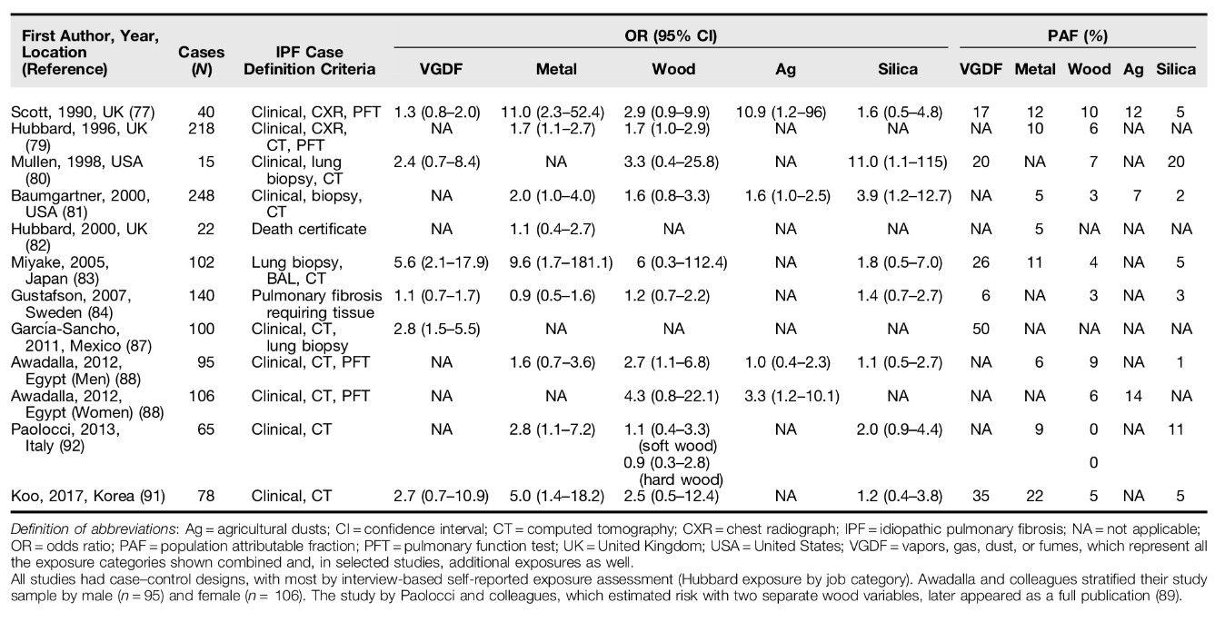

Previous IPF case-control studies reporting on occupational exposures. (Blanc 2019)

There was considerable heterogeneity in case-control studies of occupational exposure in IPF, I2 = 95% for the six studies reporting of general (vapors, gas, dust and fume) occupational respiratory exposures.[22] This may be due to real clinical diferrences in the populations studied or due to chance, publication bias, or methodolgical issues. To investigate possible publication bias I looked for funnel plot assymtetry using data from the ERS/ATS taskforce metanalysis[22]. I found evidence of publication bias for VGDF, and Metal dust ((Egger’s test p = 0.04) but not for wood dust (Egger’s test p = 0.1) and not for agricultural dust (Egger’s test p = 0.58). However, caution must be excercised in the interpetation of this since tests of funnel plot assymtetry are underpowered to distinguish chance from real assymtetry when fewer than 10 studies are being considered.[**???**]

Considering the possibility of methodological issues I tabulated study case and control definitions and exposure measures and assessed the risk of bias using RoB-SPEO[25], a tool for assessing risk of bias in studies estimating the prevalence of exposure to occupational risk factors. Seven[26][42][30][33][**???**][38][40] of the twelve case-control studies considered in the meta-analysis used population controls. One study[31] used a pension fund record to select cases and controls, one study used an orthopaedic practice list[29], and three studies used respiratory inpatients or a mix of respiratory inpatients and outpatients[32][37][40] Two studies did not match on age or sex[38][32] and one study matched on age only.[**???**]

Where participation rates were reported for community controls they were generally low, for example one study which mailed a questionnaire to potential participants had a response rate of 32.4% for controls.[29] In another study using a mailed questionnaire 60% of controls returned a completed questionnaire.[26] One study that made use of a companies pension fund records was only able to locate occupational records for 40% of cases and 38% of controls.[**???**]

Seven of the studies used only a questionnaire alone to measure occupational exposures.[26][29][**???**][33][37][38] Questionnaires reportedly asked directly about exposures of the format ‘‘In your work, have you ever been exposed to y?’’[**???**] but are unfortunately unpublished. Two studies reported blinding of assessors.[**???**][40] None of the studies were pre-registered.

Application of the Rob-SPEO tool[25] revealed that in general case control studies of occupational exposure in IPF to date are at high risk of selection bias due to low participation rates, recruitment from sources likely to be associated with exposures under study e.g respiratory inpatients, and lack of matching. The majority of studies also had a high risk of bias from exposure misclassification and/or incomplete exposure data through reliance on questionnaires that used yes/no questions for a limited number of specific exposures, bias due to lack of blinding, and possible bias due to differential reporting of exposures given that none of the studies appear to be pre-registered.

I used 40 risk estimates from 12 publications (1326 IPF cases in total) to perform a metanalysis.[26] [28] [29] [30] [31] [32] [33] [35] [36] [37] [38] [40] Three studies were not used, one because data was not collected on the proportion of cases with specific occupational exposures[27], one because of methodological differences in exposure assignment[34], and one because if reported data for pulmonary fibrosis rather than IPF.[39] Each exposure category was assessed with 6-11 risk estimates (Table 2.2).

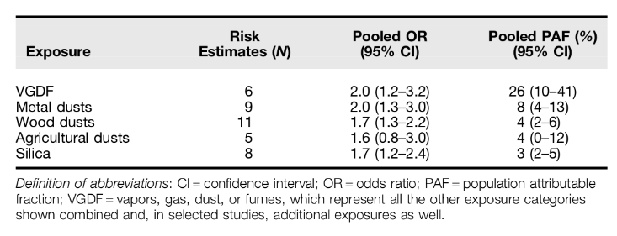

Pooled population attributable risk factors for occupation and idiopathic pulmonary fibrosis. (Blanc 2019)

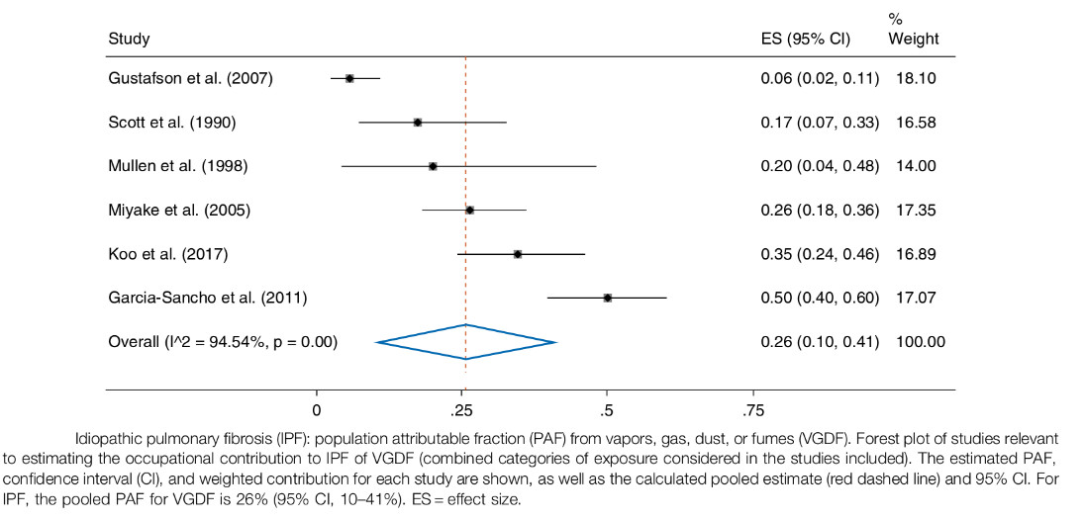

Forrest plot of pooled population attributable risk factors for occupational VGDF exposure and idiopathic pulmonary fibrosis. (Blanc 2019)

## Discussion

My results support the case for a proportion of IPF cases being attributable to occupational exposures.

Pooled ORs were significantly elevated for VGDF, metal dust, wood dust, agricultural dust, and silica dust; the pooled PAF estimates by category ranged from 4-23%. This is an important finding for an otherwise idiopathic disease which carries significant morbidity and mortality; identifying causal occupational agents could permit remediation and prevention.

Associations between IPF and wood, metal, and agricultural dust were previously reported in a meta-analysis of six case-control studies by Taskar and Coultas. [20] While my findings are similar I found a smaller effect size for agricultural exposure and a large effect size for non-specific vapours, gases, dust, and fumes (VGDF), see Table 2.2.

Funnel plot asymmetry using Egger’s test, which may be due to publication bias, was present for VGDF (p = 0.04) and metal dust (p = 0.03) but not for wood dust (p = 0.09), silica dust (p = 0.2), and agricultural dust (p = 0.6). However, the number of studies included is small and funnel plot assymetry may be due to chance rather than bias.

There are several limitations to the meta-analysis that arise from the case-control studies included.

Several studies [26] [42] [30] [33] [36] used population controls but do not provide details on participation rates. Participation rates can be low for community controls; a recent UK case-control study investigating prothrombotic factors in IPF reported a response rate of 28% for commumnity controls. [43] Where participation rates were reported for community controls they were generally low, for example one study which mailed a questionnaire to potential participants had a response rate of 32.4% for controls.[29] In another study using a mailed questionnaire 60% of controls returned a completed questionnaire.[26] One study that made use of a companies pension fund records was only able to locate occupational records for 40% of cases and 38% of controls.[**???**] The low participation rates seen, associated with commmunity controls, are vulnerable to non-responder bias.

Nearly all studies relied on self-reported exposures rather than life time occupational histories to assess exposure; an approach that is prone to recall bias and does not permit examination of dose-response relationships.

Reliance on self-reported exposures also means that studies are potentially vulnerable to confounding as a result of co-exposure. For example, several studies have described strong associations between metal work and IPF and specify sheet metal workers[27][26][31], a group who are frequently exposed to dust containing asbestos fibres[44] and who in a recent UK study, had the highest risk of mesothelioma.[45]

Case definitions and sources for cases varied between studies. For example Scott (1990)[26] used a case definition which included a chest radiograph showing bilateral interstitial shadowing whereas most other studies relied on high resolution CT. Four studies used mortality data [27][34][33][31] to identify cases and one study[33] used a national register of patients receiving oxygen therapy. Differences in healthcare coverage and coding practices can result in selection bias.[46]

## Conclusion

The observed excess risk could represent disease misclassification of pneumoconiosis or hypersensitivity pneumonitis, but this is unlikely to fully explain the observed effects. My analysis supports an etiologic role for occupational exposures in IPF, potentially explaining up to 23% of the burden of disease and highlighting a role for workplace exposure reduction in disease prevention.

# Mortality analysis: do mortality trends support an occupational cause?

## Introduction

The incidence of Idiopathic pulmonary fibrosis (IPF) has been increasing at an average rate of 5% per annum for the period 1979 to 2016.[2] By definition, the diagnosis of IPF is not made in the presence of an identifiable cause. However, the distribution of the disease in the population (more common in men, manual workers, and those living in more industrial areas of the country) suggests a causal contribution from an occupational or environmental source.

I hypothesised that a proportion of Idiopathic Pulmonary Fibrosis (IPF) cases are due to occult environmental or occupational exposures to asbestos dust. This would be expected to result in a spatio-temporal association between IPF, Mesothelioma, and Asbestosis mortality patterns coinciding with asbestos exposure. It would also be expected to produce a birth cohort effect.

I examined trends in IPF, Mesothelioma, and Asbestosis mortality data for evidence of cohort effect and association.

## Method

I obtained regional age and sex stratified mortality data for IPF, Mesothelioma, and Asbestosis for England and Wales from the Office of National Statistics for the period 1974–2012. Data were age-standardised and visualised using the Python Pandas data analysis library and matplotlib. For regional analysis poisson regression of counts was used adjusting for age and sex.

## Results

IPF, mesothelioma, and asbestosis mortality rates increased thorough the study period. IPF increased at a rate of approximately 5% per annum. The Female:Male for IPF is approximately 1:1.6 and there are more IPF deaths in the North West and South East of England. IPF mortality does appear to correlate with mesothelioma mortality (Figure ). There is evidence of a cohort effect with age-specific IPF death rates increasing in successive cohorts, most clearly seen from age 60 (Figure ). While overall rates were higher for men but there were not marked sex differences in cohort mortality trends. There was not a clear relationship in regional mortality for IPF, Mesothelioma, and Asbestosis (Table 1).

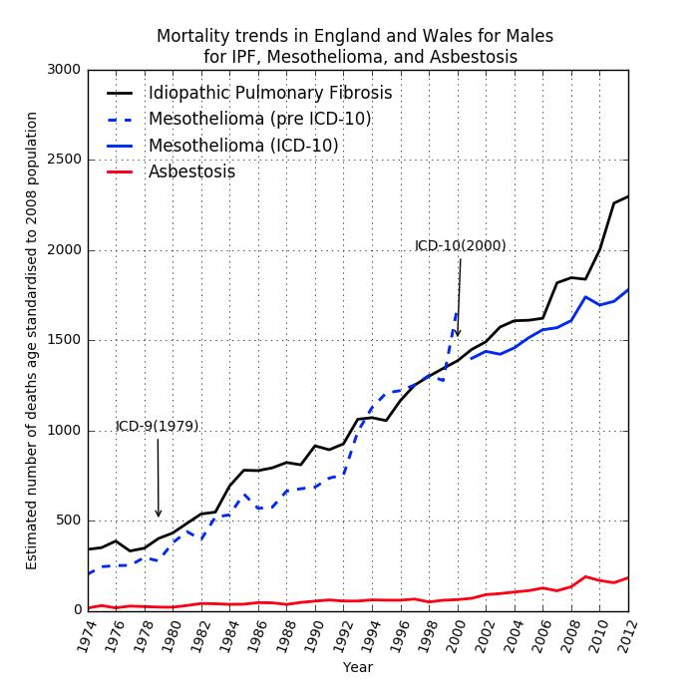

IPF, mesothelioma, and asbestosis mortality trends

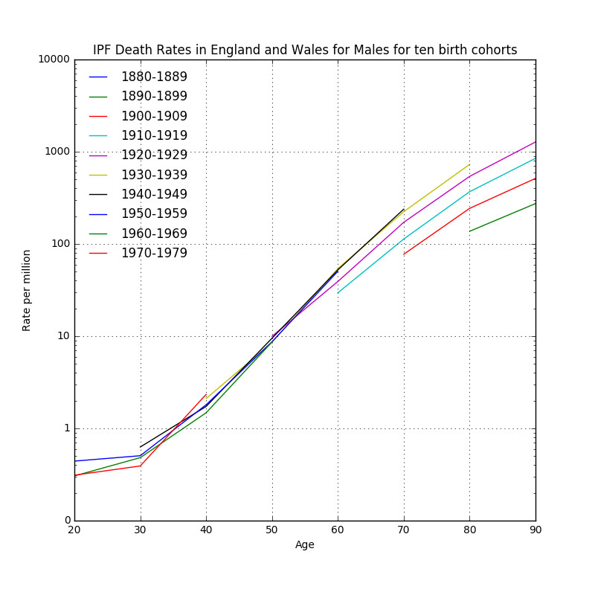

IPF male birth cohort age-specific mortality rates per million 1880-1979

### Table 1: Regional IPF, Mesothelioma, and Asbestosis mortality 1974-2012. OR (95%CI).

|  |  |  |  |
| --- | --- | --- | --- |
| Region | IPF | Mesothelioma | Asbestosis |
| North West | 1.3(1.26-1.35) | 0.99(0.95-1.03) | 2.28(1.89-2.74) |
| Wales | 1.28(1.23-1.33) | 0.61(0.58-0.65) | 1.09(0.84-1.4) |
| North East | 1.24(1.19-1.29) | 1.71(1.64-1.79) | 5.7(4.74-6.86) |
| West Midlands | 1.2(1.16-1.24) | 0.76(0.73-0.8) | 1.19 (0.95-1.48) |
| East Midlands | 1.16(1.12-1.21) | 0.78(0.75-0.82) | 1.4 (1.12-1.74) |
| Yorkshire and the Humber | 1.11(1.07-1.15) | 1.1(1.06-1.15) | 1.62(1.32-1.98) |
| South West | 1.1(1.06-1.13) | 0.87(0.83-0.9) | 1.81(1.49-2.2) |
| London | 1.01(0.97-1.05) | 1(0.96-1.04) | 2.15(1.77-2.6) |
| South East | 0.9(0.87-0.93) | 0.95(0.92-1.31) | 1.31(1.09-1.59) |
| East | 1 | 1 | 1 |

## Discussion

I found evidence of a cohort effect whereby age specific-specific IPF death rates have increased in successive cohorts. These findings are similar to a recent study by Navaratnam et al using the same data source[2] and mesothelioma birth cohort age adjusted mortality trends.[47]

Mortality data for IPF has the advantage of capturing a sufficiently large number of deaths to permit analysis of trends over time with a reasonable degreee of confidence. The accuracy of reports over time may have varied, this is a potential consequence of coding changes since prior to 2000, and the use of ICD-10, there was not a unique code for IPF and thus some ambiguity as to how it should be coded. However, a death certification validation study using an IPF cohort of 211 incident cases diagnosed in England and Wales between 2010 to 2012 found that of the 124 deaths occuring in study period 83(67%) had IPF coded as the underlying cause of death and 102(82%) had it coded anywhere on the death certificate.[6] Therefore capture is good and estimates of disease prevelence based on mortality are likely to be conservative.

The close correlation between IPF and mesothelioma mortality in the UK has been observed by others[9] who reported pearson correlation coefficients of 0.98 (p<0.001) for men and 0.97(p<0.001) for women and noted that lagged historic asbestos imports also correlate strongly with IPF and mesothelioma mortality in the UK. Alternative explanations for the rise in IPF cases include increased recognition of cases[2] and overdiagnosis on the basis of CT criteria.[48]

## Conclusion

There is an unexplained sustained increase in the incidence of IPF and a very suggestive, if ecological, association with mesothelioma and lagged historic asbestos imports. There does appear to be a birth cohort effect whereby age specific rates are higher in later cohorts that would, for the data considered, be consistent with historic occupational asbestos exposure and a long latency between exposure and disease.

# Historic asbestos exposure assessment: can it be done?

## Introduction

Asbestos related respiratory disease is initiated by inhalation of asbestos fibres. In the UK clinically significant asbestos exposure is largely occupational and, as a result of asbestos control legislation, historic.

Occupational asbestos exposure can be assessed quantitatively by sampling ambient air at a workplace and calculating a fibre count using microscopy. Alternatively, because inhaled asbestos fibres persist in the lung they can be sampled by lung biopsy, bronchoalveolar lavage, or at autopsy.

Historic workplace measurements are a valuable resource for assessing exposure but are limited in several ways. Measurements are not available for many occupations, where measurements are available they are dependant on working practices and measurement technique at the time of assessment; they do not necessarily generalize well.

Measurement of asbestos fibres in lung tissue by means of biopsy or bronchoalveolar lavage is invasive and both procedures carry the risk of serious complication including death. Additionally, the biopersistence of asbestos fibres is variable, the physical characteristics of inhaled fibres may be modified in-situ[49], counts are sensitive to techniques used, and establishing appropriate references ranges is challenging.[50]

Expert assessment and exposure modelling approaches integrate historic workplace measurements with simulated workplace measurements and an individuals recollection of job processes he or she has carried out during their working life.[51]

Job-exposure matrices (JEMs) are widely used in occupational epidemiology studies to assess exposure to potential hazards. These assign levels of exposure to health hazards on the basis of job title.

Finally, self-reported exposures are a subjects direct report of what they have been exposed to, these are usually elicited by questionnaire or at interview.

The asbestos exposure assessment literature presents difficulties for review because it is large and recognised to be at risk of bias as a result of its economic importance to powerful industrial and medicolegal actors[52].

Here I critically review different means of historic asbestos exposure assessment and consider their clinical and research utility.

## Method

I searched pubmed and google scholar for combinations and synonyms of “asbestos”, “exposure assessment”, together with terms for modes of assessment including “lung biopsy”, “bronchoalveolar lavage”, “exposure reconstruction”, and “job-exposure matrix”. When a relevant papers was identified, papers referenced, and papers citing, the paper were reviewed.

## Results

### Lung biopsy and bronchoalveolar lavage

The first report of fibrosis of the lung due to asbestos dust[53] included a description of the post mortem microscopic appearances of the lungs which showed abundant asbestos fibres in areas of fibrosis.

The demonstration of asbestos fibres on lung biopsy in the context of pulmonary fibrosis is clearly supportive of the diagnosis of asbestosis. However, a failure to demonstrate fibres can not be used to rule out asbestos exposure because fibres, particularly chrysotile fibres, may be cleared from the lung and counting methods have a significant false-negative rate.[50]

Despite this recent 2014 Helsinki guidelines[54] and UK Royal College of Pathologists guidelines appear to suggest that a clear history of substantial occupational asbestos exposure is insufficient for diagnosis and that the absence of asbestos bodies or fibre counts above a certain threshold may be used to rule out the diagnosis. The shortcomings of such an approach highlighted above are also described by responses to the Helsinki guideline.[55][56][57]

Lung biopsy carries significant health risks, particularly for patients who already have compromised lung function and it can not be justified solely on medico-legal grounds.[56] Therefore, the clinical utility of lung biopsy and bronchoalveolar lavage is limited to ruling in asbestosis when a suggestive exposure history and radiology are lacking.

In a research context lung biopsy and bronchoalveolar lavage have provided valuable population level insights. Lung biopsy asbestos fibre counts have been examined in a UK case-control study where mesothelioma cases were compared with lung cancer controls. Fibre counts were found to be higher in groups with greater occupational risk (as defined by PMR), providing additional support for the pre-eminence of an occupational history.[45][58] In a follow up study asbestos fibre counts from unselected surgically treated pneumothorax patients were used to demonstrated that population amphibole burden is falling and is proportional to mesothelioma mortality.[59]

A similar correlation with occupational exposure history, overall downward trend in fibre counts, and a significant false negative rate has been observed in a recent Belgian study of patients undergoing bronchoscopy with bronchoalvelolar lavage sampling for asbestos fibre quantification.[60]

### Historic workplace measurements

Occupational hygienists have recorded a large numbers of workplace measurements of asbestos in different settings, at different times, using a variety of different means. These measurements reside in national databases such as the HSE National Exposure Database[61], and EV@LUTIL[62], in the published literature, and in unpublished company records.

The use of different means of making workplace assessments results in difficulties with respect to the accuracy and comparability of measurements. For example, instruments that count particles rather than asbestos fibres have been used and there is no established conversion factor.[63] Phase contrast microscopy has also been used which is less sensitive that scanning electron microscopy, which is in turn less sensitive than transmission electron microscopy and energy-dispersive x-ray analysis.[64]

Where era and task specific workplace exposure data matching a particular patient occupational history is available and readily obtainable it is a valuable means of assessing exposure history. Unfortunately in practice measurements are usually limited to the subset of jobs thought to be potentially harmful “high” exposure jobs at the time of measurement. As awareness of the sources and harm of asbestos exposure has developed overtime the available data, until the use of asbestos was banned in the UK, is also skewed to more recent times.[65][66]

Measurements have found greater utility in a research setting where they can help to quantify risk and inform regulatory policy and compliance in specific workplace settings, for example, in car mechanics[67] or skilled craftsmen.[68]

### Exposure reconstruction

Sahmel et al[66] propose a seven-step framework (see Figure ) which they use to enumerate and critique exposure reconstruction approaches.

Reconstruction techniques may be quantitative, semi-quantitative, or qualitative. Quantitative exposure reconstruction bases exposure estimates on data from similar (historic or current) exposure scenarios or simulation studies. Semi-quantitative exposure reconstruction bases exposure estimates on exposure data matrices (using a job-exposure matrix) and/or exposure determinants (using an exposure model). Qualitative exposure reconstruction bases exposure estimates on the expert judgement of an industrial hygienist and self reported exposures.[66]

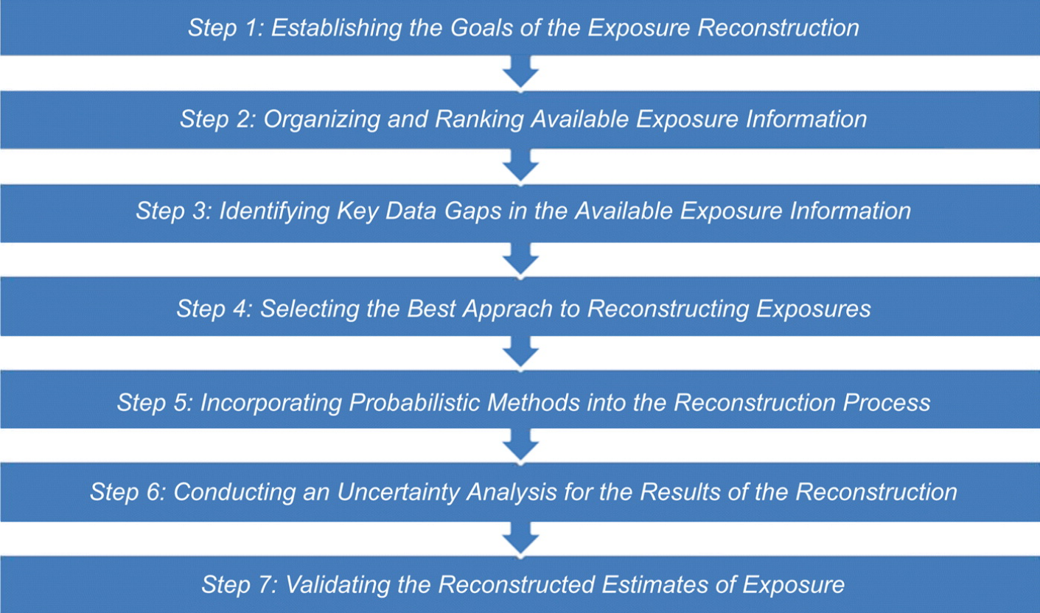

Seven step framework for exposure reconstruction

#### Job-exposure matrices

Several job-exposure matrices that deal with asbestos have been reported. Pannett et al’s 1985 job-exposure matrix for use in population studies in England and Wales[69] found good agreement between job-title assigned categories of exposure (none, low, moderate, high) for asbestos and direct review of the original occupational history by an expert.

Rake et al[45] assigned categories risk of exposure (low, medium, high) using occupational mortality statistics for pleural mesothelioma. Because pleural mesothelioma in men is nearly entirely attributable to occupational asbestos exposure, pleural mesothelioma is rapidly fatal, and UK death certificates record occupation in addition to cause of death, the proportional mortality ratio for pleural mesothelioma (standardised pleural mesothelioma mortality in a given occupation/standardised pleural mesothelioma mortality across all occupations) can serve as proxy for average asbestos exposure in a particular occupation. This approach has been validated in the same cohort by transmission electron microscopy asbestos fibre counts.[58]

DOM-JEM[70] was developed for use in a population based multi-centre lung cancer case-control study conducted in seven european countries. It assigns job titles one of three categories of asbestos exposure (no exposure, low exposure, high exposure) based on the consensus of three independent expert raters. DOM-JEM showed poor agreement with expert assessment () but less heterogeneity across countries than a population based JEM and expert assessment. A study applying DOM-JEM to the Netherlands Cohort Study (NCS) DOM-JEM also showed poor agreement with expert assessment (K = 0.29).[71]

The Finish Information System on Occupational Exposure (FINJEM)[72] covers exposure to 84 different agents, including asbestos, for 311 jobs across 9 periods spanning 1945-2015. Era-specific estimates of the mean level of asbestos exposure are available for 27 jobs based on expert assessment and measurement data; the exact details of the grounds for estimates are kept in a proprietary FINJEM database which is sadly not freely available. FINJEM showed poor agreement with expert assessment of asbestos exposure () but reasonable identification of mesothelioma risk when evaluated using the NCS.[71][73]

AsbJEM[74] was developed in Australia by an expert panel of three industrial hygienists using all available exposure data. It is based on FINJEM and provides quantitative estimates of annual exposure for 224 occupations across three time periods spanning 1943 to 2004. It also showed poor agreement with expert assessment of asbestos exposure ().[71]

SYN-JEM[75] describes a JEM developed for four carcinogens. It provides quantified asbestos exposure estimates based on 27958 personal measurements (spanning 1971-2009), a mixed effects statistical model, and a priori categorical assessment of exposure (none, low, high). Cherrie et al[76] point out that SYN-JEM provides little contrast in the modelled exposure level between categories as the geometric mean for low jobs was 0.061 fibres/ml and for high jobs 0.074 fibres/ml and that there are wide variations in regional estimates that are difficult to explain.

JEMS are generally taken to be superior to direct questions about exposures because they are cheaper, have greater validity, and are less vulnerable to differential recall. This is because recall of occupations is not influenced by disease status, coding of occupation is blind to case-control status, and translation of codes into exposure is standardized and can not be influenced by disease status of a subject.[77][78][79]

Orlowski et al[80] compared two JEMs with a structured job specific questionnaire (SQ) in a lung cancer case-control study. They found that agreement between the JEMs and the SQ was poor () and suggested that the sources of error for JEMs were loss of information due to the use of job codes as surrogates for job task descriptions and the insufficiency of published data on occupational asbestos exposure.

JEMs are not routinely used in clinical practice because they are not usually available or accessible for specific patients. In a research setting they are frequently helpful though in addition to the strengths and weaknesses outlined above the desirability of reusing an existing JEM vs developing a study specific JEM must be considered.

#### Exposure modelling approaches

Exposure modelling approaches modify existing measurement data on the basis of knowledge of the determinants of exposure. They may be viewed as the formalization of professional decision criteria used by hygienists in their assessment of workplace exposures.[65]

A common conceptual framework for this is the source-receptor model[81][65] whereby inhalation exposure is considered in terms of an exposure source, a pathway from source to receptor, and the receptor. The model is then used to propose modifying factors such as activity emission potential, substance emission potential, localized control, worker behavior, surface contamination and respiratory protection.[81].

In the hands of some hygienists assessment of historic asbestos exposure based on interview can correlate well with amphibole fibre counts.[82] By extension, exposure modelling approaches, using industrial hygienist methods, might be expected to be useful. Exposure modelling approaches make strong intuitive sense; it is known that there is significant within-worker and between-worker variability in occupational exposures[83] and, for example, room size and ventilation have been empirically shown to affect the concentration of airborne chemical exposures.[84] Further, mathematical exposure models that take account of known exposure modifying factors to estimate past exposures have shown a good correlation with measured values.[51]

A quantified validated historic asbestos exposure model[76] has recently been developed and proposed as a means of for risk stratifying asbestos exposed workers to optimize mesothelioma screening efforts. The approach has the advantage, compared with job-exposure matrices, of providing a more granular quantified exposure assessment, sensitive to the exposure circumstances of the individual. However, the approach is limited by the fact that the individual must recall their exposure circumstances which due to the latency of asbestos related disease may have occurred over 30 years ago. The approach is also limited by the relatively small number of industry-specific data points used for validation, though though is unavoidable because of the scarcity of exposure measurement data.

Exposure modelling approaches to assessing asbestos exposure have research and clinical utility notwithstanding the limitations outlined above together with the requirement that assessors be appropriately trained.

#### Self-reported exposure

Self-reported exposures are a subjects direct report of what they have been exposed to. Typically this is elicited by asking about a specific exposure via questionnaire or interview. Differential recall of self-reported exposures according to disease status is a concern but few studies have found evidence of this and it appears to be less of an issue when prompted responses, rather than volunteered, responses about occupational exposures are used.[85]

Most studies comparing self-reported exposures to industrial hygiene measurements have found significant associations but with wide variation in the proportions of variance explained by the self reports. This is not surprising given that it is known there is significant within-worker and between-worker variability in occupational exposures.[78][83]

Studies comparing self-reported exposures to expert assessment find highly variable levels of agreement () with a median . In two studies comparing self-reported exposures with JEMs, self-reported exposures were more sensitive and of similar or worse specificity.[78]

Self-reported exposures have been shown to be more accurate for easily sensed exposures such as solvents with a strong smell, dusts with larger particle sizes, and vibrations that can be felt. Providing a reference point, for example using well known machines from a workplace to gauge noise category also improves accuracy.[78]

Self-reported exposures have clinical utility in that they can suggest or support consideration of an occupational cause for disease. Ideally such self-reports are combined with the clinicians knowledge of the likely occupational exposures given the occupational history and other available data to strengthen or weaken the case as appropriate. Similarly, they have utility in a research setting where they may augment other means of assessment.

## Discussion

The accuracy of historic asbestos exposure assessment, by any means, is limited by the paucity of occupational asbestos measurement data, measurement technique limitations, within and between worker exposure variability, and participant recall. There does not exist a universally agreed “gold standard” against which to evaluate methods. Accurate quantified assessment of historic exposure, where evidence is scarce, may be an impossible task.[86]

Nonetheless, clinically, historic asbestos exposure assessments must be made for attribution. Specifically, to inform whether the required threshold of asbestos exposure (as assessed by various means) has been crossed so it is possible to say that, for example, scarring of the lung with an usual interstitial pneumonia pattern in an individual patient is caused by asbestos exposure. This carries medicolegal in addition to scientific importance and has not been well established by any assessment method.

In the context of mesothelioma case-control studies fibre-counts do at least provide an objective means of assessing historic asbestos exposure against which other means can be compared. It is encouraging that industrial hygienist assessment and assessment using job title and PMR correlates strongly with fibre counts.[79][58] Further and more generally, it is encouraging that estimates from explicit asbestos exposure modelling systems such as Cherrie et al’s[76], show good correlation with measurement data.

## Conclusion

Quantitative estimates of historic occupational asbestos exposures will generally have high uncertainty. However, less precise measures, such as relative difference in exposure among epidemiological groups may be quite certain even though the numerical estimates are only approximate. This is invaluable in studies examining aetiological hypothesis.[65]

# MUC5b + environmental insult = IPF?

## Introduction

### Mucus, Mucins, MUC5b: structure, function and evolutionary importance

Mucus is an essential part of the innate immune system, considered to be universal within most phyla of both aquatic and terrestrial metazoans. It plays a pivotal role in the prevention of disease by serving as an antimicrobial barrier, it also has physiological functions including allowing the exchange of oxygen, carbon dioxide, nutrient and metabolites, lubricating surfaces and reducing damage due to sheer, reducing dehydration of the epithelia and providing the polymeric matrix which enables ciliary-mucus particle transport.

Mucus barriers are essential for the separation and protection of an organism from its external environment, and likely a prerequisite for the exclusion of bacteria from bodily tissues and evolution of gastrointestinal and respiratory tracts. The importance of mucus barriers is further underlined when one considers the energy investment continuous mucus production and release requires; for example, corals use mucus to trap particles and transport them towards their mouths and the reef-building coral Acropora acuminata is thought to dedicate up to 40% of its daily net carbon fixation (energy from photosynthesis) to this task alone.[87] Mucins are a key component of mucus, they are highly evolutionary conserved large glycoproteins that date back around 600 million years to Nematostella vectensis, the starlet sea anemone, which is an early marine invertebrate. The earliest human mucin analogue is found in Xenopus tropicalis, the African clawed frog, which evolved about 300 million years ago and mucins are the likely explanation for the observation that frogs show such great resistance to infection during dissection and it has been shown that knockdown of mucin in the skin mucus barrier of Xenopus tropicalis tadpoles leads to susceptibility to infection by the opportunistic pathogen Aeromonas hydrophila.[88]

The mucin family is composed of proteins that contain tandom repeat structures with a high proportion of prolines, threonines, and serines; the PTS domain. It is further defined by extensive glycosylation of the PTS domain through N-Acetylgalactosamine O-linkages at the threonine and serine residues.[89] The resultant oligisaccharide chains and polymeric structure create the viscoeleastic properties of mucus which confer its barrier properties and play an important role in storage and secretion. [87] Mucins are 50-90% carbohydrate and they are anionic because most of their terminal sugars contain carboxyl or sulphate groups. Mucin glycan helps to sequester pathogen by acting as a ‘decoy’ and providing sites for microbial adhesins to bind; for example, human salivary MUC5b interacts with streptococcal species, and patterns of glycosylation change during inflammation.[90][91] Mucin barriers can be subverted by pathogens, strategies include production of enzymes to degrade mucin core proteins and mucin carbohydrates, and evolution of effective motility through mucus gels - many mucosal bacterial pathogens are flagellated for this reason. There is evidence that degradative enzymes are required for pathogenesis in species such as Vibrio cholorae and that flagella are required for infectivity in species such as Helicobacter pylori.[90] Intracellular gel-forming mucins are stored in a compact and condensed form in granules within mucus-secreting cells. They are stored in solution with a high concentration of calcium ions and protons which is thought to be necessary to mask the anionic charge and prevent electrostatic repulsion, upon secretion mucins expand 1000-3000 fold taking up water to form a gel as calcium is exchanged for sodium and the pH rises.[87] One consequence of mucins being stored in such a compact form is that when they’re released they can obstruct the airway which in mouse models appears necessary for the clearance of helminth infection[91] and may provide a clue to their evolution.

Normal human airway mucus is a hydrogel composed of approximately 98% water, 0.9% salt, 0.8% globular proteins, and 0.3% high-molecular-weight mucin polymers.[92] Mucin hypersecretion may increase the concentration of solids up to 15% resulting in viscous elastic mucus that is not easily cleared.[93] 17 genes encode mucins in the human genome of which the gene products of seven are secreted and the remainder are membrane bound. Five of the secreted mucins have terminal cysteine rich domains that can form disulfide bonds resulting in polymers that impart the properties of a gel. MUC5AC and MUC5B, two secreted gel-forming mucins, are strongly expressed in the human respiratory tract. MUC5AC is predominantly expressed in the conducting airways and MUC5B is predominantly expressed in the respiratory airways (muc5b is also expressed in salivary glands, cervix, gallbladder, seminal fluid, and middle ear epithelium). Secreted mucins are large glycoproteins (up to 3x10^6 D per monomer), ranking among the largest molecules encoded in mammalian genomes, and their expression induces and requires an endoplasmic reticulum stress response.[94] Mucin production and secretion are regulated by distinct mechanisms. Production is highly regulated at transcriptional level. The ErbB family of proteins contains four receptor tyrosine kinases, structurally related to the epidermal growth factor receptor (EGFR), its first discovered member. ErbB-receptor signaling appears important for MUC5AC production since inhibition blocks MUC5AC up-regulation by diverse stimuli. Interleukin-13 (IL-13) is a cytokine secreted by T helper type 2 (Th2) cells, natural killer T cell, mast cells, basophils, and eosinophils. IL-13 is a central regulator in IgE synthesis, goblet cell hyperplasia, mucus hypersecretion, airway hyperresponsiveness, fibrosis and chitinase up-regulation. It is a mediator of allergic inflammation and different diseases including asthma. IL-13 appears important because it increases MUC5AC expression (IL-1 beta appears to be an important stimulus for MUC5b expression[91]). Basal levels of production and secretion of MUC5AC and MUC5B change as part of an allergic response. The production of MUC5AC can increase 40-200 times as high as normal levels in humans with similar findings in mice, MUC5B increases more modestly, 3 to 10 times in mice. The most important stimulus for secretion appears to be ATP which acts on apical membrane purinergenic (P2Y2) receptors. Once secreted mucus gel is propelled in a proximal direction towards the mouth, by ciliary beating as part of the mucociliary escalator, where it is expectorated or swallowed. [93]

### MUC5b rs3570950 and respiratory disease

Expression and localisation of MUC5AC and MUC5B is different in patients with lung disease compared with healthy controls. MUC5AC expression is increased in asthma for example, while MUC5B expression is increased in COPD[95] and IPF. In COPD MUC5b expression occurs in more proximal airways, whereas in IPF it localised to the bronchiole.[96] MUC5b appears to be particularly important in IPF.

The gain of function promoter variant rs5270590, 3.5 kb upstream of the mucin 5b (MUC5B) transcriptional start site, is the strongest identified risk factor (genetic or otherwise) for the development of either sporadic or familial IPF. The largest study to date (1616 non- white patients with fibrotic interstitial pneumonias and 4683 controls) estimated that the odds of developing pulmonary fibrosis for those with one copy of the risk allele were 4.5 times (95% CI: 3.9, 5.2) the odds of those with no copies and that the odds for those with two copies are 20.2 times those with no copies (95% CI: 15.2–27.0).[97] The strength of association is substantially higher than for most other common risk variants for complex disease with the exception of the human leukocyte antigen (HLA) region for some autoimmune diseases such as type-1 diabetes mellitus and systemic lupus erythematosus which have OR greater than 10. The association between rs35705950 has been replicated in 3 genome wide association studies (GWAS) and a total of 10 independent cohorts including a Mexican cohort and two Asian cohorts and is thought to account for about a third of IPF cases.[98] However, penetrance is low with up to 20% of non-Hispanic whites having at least one copy of the variant yet IPF occurring only rarely (prevalence < 1%) . The rs35705950 variant is a G-to-T transversion that occurs in an area of the MUC5B 5’ flanking region, a region which has characteristics of being an enhancer subject to epigenetic control via DNA methylation and histone modification.[96] An enhancer is a sequence of DNA that functions to enhance transcription. A promoter is a sequence of DNA that initiates the process of transcription. A promoter has to be close to the gene that is being transcribed while an enhancer does not need to be close to the gene of interest. Publicly available data through the Encyclopedia of DNA Elements (ENCODE) suggest MUC5b promoter site is a complex area of the genome with many transcriptional factors showing evidence of binding.[99] In other words MUC5b expression is likely a function of genetic and non-genetic factors.[98] In addition to IPF, rs35705950 has been found to be positively associated with interstitial lung abnormalities (ILA), chronic hypersensitivity pneumonitis (CHP), rheumatoid arthritis associated interstitial lung disease (RA-ILD), and myeloperoxidase-antineutrophil cytoplasmic antibody-associated vasculitis associated interstitial lung disease (AAV-ILD).[100] It has also been found to not be associated with cutaneous systemic sclerosis interstitial lung disease (SSc-ILD), sarcoidosis, and myositis-ILD. [101]

#### Potential role in IPF pathogenesis

The rs5270590 variant is associated with a 34 fold increase in expression of MUC5b compared with wild type in healthy control populations and a 5 fold increase in patients with IPF (see figure 1).[98] In IPF patients distal airway MUC5b is expressed preferentially, compared with MUC5Ac. MUC5b is also expressed in honeycomb cysts, a defining characteristic of the usual interstitial pneumonia CT pattern typically seen in IPF.[102]

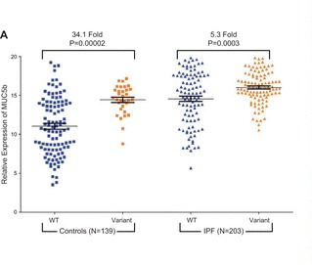

MUC5b expression (Evans 2016)

Proposed mechanisms for the role of the rs5270590 variant in the pathogenesis of IPF include:

1. Excessive production of MUC5B by stem cells that attempt to regenerate injured bronchiolar and alveolar epithelium could disrupt normal development pathways and highjack normal reparative mechanisms of the distal lung resulting in fibroprolferation and honeycomb cyst formation.
2. Excessive MUC5B production leading to reduced mucociliary function, retention of particles, and enhanced lung injury.
3. Interaction between MUC5b and motile cilia since distinct cilium gene expression in IPF lung has been observed.
4. Excessive MUC5b production inducing endoplasmic reticulum stress and the unfolded protein response.[98]

Muc5b has been studied in mice. A muc5b knockout mouse study found that muc5b is essential for mucociliary clearance, for controlling airway and middle ear infections, and maintaining immune homeostasis in the lungs. Knockout mice had airflow limitation and died from infection by multiple bacterial species, including Staphylococcus aureus.[103] A transgenic muc5b mouse model of muc5b overexpression found that overexpression causes mucociliary dysfuction and enhances lung fibrosis on response to bleomycin.[104] Intriguingly, in recent bleomycin lung fibrosis model studies lung fibrosis was attenuated and mortality reduced in both germ-free mice and IL-17B deficient mice supporting the concept that fibrosis in response to epithelial injury is mediated by interaction of the immune system with microbiota.[105][106]

### Infection and immunity

The frequency of the disease associated allele at rs35705950 exceeds 10% in European populations (https://www.ncbi.nlm.nih.gov/snp/rs35705950) but is less than 1% in African and East Asian populations. Clearly the rs35705950 variant is not subject to negative selection due to IPF risk since onset is well after the reproductive age begins[98]; the variation in frequency observed is consistent with strong positive selection. The increased MUC5b expression in the airways associated with the rs35705950 variant may have conferred a survival advantage by providing protection against lung infection. [94][91] A relation between the rs35705950 variant, disease risk, and infection is also supported by the observation that in a prospective study of 65 IPF patients and 44 COPD and health controls, IPF patients had higher bacterial loads than COPD and healthy controls and within IPF patients those with homozygous (TT) for variant had significantly lower bacterial loads (P=0.01), measured by 16S rRNA quantitative polymerase chain reaction of bronchoalveolar lavage samples. Within IPF those with higher bacterial loads were also at increased risk of death.[107] These finding are consistent with observation that the rs35705950 variant is associated with improved survival in IPF[108] and fewer acute respiratory disease events in the COPDGene cohort with interstitial features.[109] However, these studies are vulnerable to index event bias, by which selection of subjects according to disease status creates biased associations if common causes of incidence and prognosis if not properly accounted for.[110] For example, it is known that the rs35705950 variant is associated with interstitial lung abnormalities[111], since the diagnosis of IPF relies heavily on radiological appearances individuals with the variant might tend to be diagnosed earlier in the course of their disease giving the false impression, when comparing them to IPF patients without the disease variant that is associated with survival. Further support for the importance of infection in IPF provided by the observation that immunomodulatory therapies such as interferon gamma, ethanercept, prednisolone, azathioprine and N-acetylcysteine have failed to prolong survival in IPF[112] to prolong survival in IPF, from a small (N = 181) double blinded randomized controlled study which found reduced symptom burden and improved survival associated with cotrimoxazole[113], as well as evidence from genetic and animal studies. IPF GWAS have identified single nucleotide variants associated with disease susceptibility in the Toll interacting protein (TOLLIP) gene, for example rs111521887. TOLLIP is an inhibitory adaptor protein within Toll-like receptors (TLR) and part of the innate immune system recognising pathogen associated molecular patterns (PAMPs)[114] and, intriguingly, in a mouse bleomycin lung fibrosis model the absence of a microbiome protected against mortality.[105]

### Inorganic occupational stimuli

The frequency of the disease associated allele at rs35705950 exceeds 10% in European populations(https://www.ncbi.nlm.nih.gov/snp/rs35705950) but its penetrance is low; the median prevalence of IPF for men and women in Europe is approximately 3.75 per 100000 for the period 2001-2013[115], which suggests other genetic or environmental factors must be at play. In addition to responding to PAMPs as outlined above the innate immune system also responds to damage-associated molecular patterns (DAMPs) which can result from inhalation of inorganic respirable toxins such as silica or asbestos.[116] Secretion of the inflammatory cytokine IL-1 beta) (which is also a stimulus for MUC5b expression) is elevated in alveolar macrophages of patients with ILD, including IPF, sarcoidosis, silicosis, RA-ILD, and asbestosis.[117][118] Inflammasome are multiprotein intracellular complexes that detect pathogenic microorganisms (PAMPs) and sterile stressors (DAMPs). The NLRP3 (NOD-, LRR- and pyrin domain-containing protein 3) inflammasome is an intracellular sensor that detects a broad range of PAMPs and DAMPs leading to caspase 1-dependent release of the pro-inflammatory cytokines IL-1 beta and IL-18, as well as to gasdermin D-mediated pyroptotic cell death.[119] Interestingly the NLRP3 inflammasome appears to be implicated, albeit with differing activation patterns[120], in all of these conditions, interaction between smoking (a risk factor for IPF) and the NLRP3 inflammasome is recognised, and recent work has shown age-dependent susceptibility to pulmonary fibrosis in a bleomycin-induced lung injury mouse model.[121] Occupational risk factors such as metal, wood, and stone dust exposure are well recognised in IPF, accounting for up to 8% of cases the basis of a meta-analysis of case-control data[22] and its likely that innate immune system activation via the NLRP3 inflammasome and other means by occupational exposures mediates this risk.

## Conclusion

The apparently complex interplay between exposure to organic and inorganic respiratory toxins, the mucus barrier, respiratory epithelium and resident cells such as alveolar macrophages in idiopathic pulmonary fibrosis remains incompletely characterised but genetic, epigenetic, gene-expression, and epidemiological studies are beginning to fill in the gaps. Gene-environment interaction between the rs5270590 variant and occupational inorganic respiratory toxins such as asbestos may modulate IPF risk and help to explain the incomplete penetrance observed. Studies to date which have selected patients on the basis of a diagnosis of IPF and then stratified by MUC5b genotype are at risk of index-event bias. A large case-control study of IPF which captures details of occupational exposures, genotype, and potential confounders, whilst also measuring factors likely to affect disease pickup such as disease severity and radiographic changes is required.

# Idiopathic pulmonary fibrosis job exposures study (IPFJES): Is occupational asbestos exposure an under-recognised cause of IPF?

## Introduction

Occult occupational asbestos exposure as a cause for otherwise ‘idiopathic’ pulmonary fibrosis has been an open question for at least 30 years. The question arises because of the clinical and radiological similarities of asbestosis and IPF; a usual interstitial pneumonia is observed in both, and patients can present in the same way (chapter 1). Patients having significant asbestos exposure, that would warrant a diagnosis of asbestosis, may go undetected because they do not recall exposure or because where they do recall exposure it is difficult to assess if the exposure is sufficient to have caused disease (chapter 4). A recent meta-analysis of IPF case control studies reporting on occupational exposures found significant associations between metal, wood, and stone dust, and IPF (chapter 2). However, the extent of confounding by groups of workers likely to have significant asbestos co-exposure, for example carpenters and metal plate workers, is unknown. The majority of these studies are limited by their reliance on self-reported binary exposure which risks recall bias and does not permit investigation of dose-response relationships which would be helpful for establishing causality. Studies to date have also not looked at the possibility of gene-environment interaction; genetic risk factors such as rs5270590 are now well established and interaction with inhaled exposures is suspected but has not yet proven in humans (chapter 5). The question of asbestos exposure in IPF is a live one globally because countries such as Brazil, Russia, India, and China, continue to consume asbestos and, closer to home, asbestos related and IPF mortality rates continue to rise; asbestos related mortality in the UK is driven primarily by pleural mesothelioma and is expected to peak in the next couple of years as a result of effective asbestos exposure control legislation, the sustained rise in IPF mortality rates is unexplained (chapter 3).

IPFJES is a multi-centre, hospital-outpatient, incident case-control study conceived to definitively address the question of asbestos exposure having a causal role in IPF. Participants were recruited from a network of 21 hospitals across England, Scotland, and Wales. Cases were men who presented, between 01/02/2017 and 01/10/2019, with a new MDT diagnosis of IPF consistent with standard criteria.[122] Controls were men who attended selected outpatient clinics in the same time period. An outpatient clinic was randomly selected to be the source clinic for the recruitment of controls at each hospital from a list of all outpatient clinics (not confined to respiratory) local research teams could recruit from. Over 460 cases and 460 controls, frequency-matched on age, were recruited to achieve a pre-defined recruitment target of 920 participants.[clinicaltrials.gov NCT03211507] Participants were interviewed by telephone by a trained interviewer who was blind to their case status using a bespoke study web application (ipfjes-interview, full source code available at www.ipfjes.org). Lifetime occupational history, smoking history, drug history, family history, and modified Medical Research Council (mMRC) dyspnoea score were recorded. Using ipfjes-interview each occupation was coded on the basis of the Office for national statistics (ONS) standardised occupational classification 1990 (SOC90) at the time of the interview. For participants who recalled carrying out work tasks with asbestos a detailed assessment of each work task was recorded. SOC90 coded jobs were used to assign asbestos exposure risk to participants using occupational proportional mortality rates for malignant pleural mesothelioma. A fibre-ml.year estimate was calculated for participants recalling asbestos exposure. All participants provided an EDTA sample from which DNA was extracted and genotyped according to IPF susceptibility single nucleotide variant (SNV) rs35705950 using Q-PCR and a Taqman assay. Unconditional logistic regression was used to analyse ‘any’ vs ‘no’ asbestos exposure and categories of cumulative exposure adjusting for age and smoking status. In a secondary analysis we used logistic regression to investigate metal, wood, and stone dust exposure (self-reported occupational exposure), and rs35705950 genotype-exposure interactions.

## Method

### Funding, approvals, and registration

We obtained funding from welcome trust (201291/Z/16/Z) and ethical approval (IRAS project ID 203355, REC reference 17/EM/0021). We also obtained NIHR portfolio status (CPMS ID 203355) and registered our study on clinicaltrials.gov (NCT03211507). Full study documentation is available online at www.ipfjes.org.

### Selection

Cases were men of any age who were diagnosed with IPF at 21 collaborating hospitals across England, Scotland, and Wales between 01/02/2017 and 01/10/2019. The diagnosis of IPF by the referring centres was made at MDT on the basis of clinical history, high-resolution computed-tomography (HRCT), and where necessary lung biopsy in accordance with standard criteria.[122] Referring centres provided HRCT report findings for all cases and histopathology report findings for cases where a biopsy was performed.

At each collaborating hospital an outpatient clinic was randomly selected to be the source clinic for the recruitment of controls from a list of all outpatient clinics (not confined to respiratory) that the local research team could recruit. If the clinic selected was unsuitable, for example because it did not contain men of a similar age to cases or the clinic lead declined to participate then this was recorded and a further random selection made. Controls were men that attended the selected outpatient clinics between 01/02/2017 and 01/10/2019. Controls were frequency-matched on age, were recruited to achieve a pre-defined recruitment target of 920 participants.

Men who were unable to give informed consent or who had worked outside of the UK for one year or more (not including work outside the UK by a member of the armed forces or merchant navy) were excluded from being cases and controls. Cases and controls were approached by local research teams and provided with the IPFJES participant information sheet. They were given opportunity to read it and ask questions and then invited to sign the consent form and provide their contact details and a blood sample if they wished to take part. Local researchers completed a case report form detailing participant demographic information, CT and biopsy results, and contact details which was sent together with the blood sample by secure post to the central research team.

### Measures

A trained interviewer (RS or CR) who was blind to the case status of participants conducted the study interviews by telephone. Interviews were recorded for quality control purposes. The interviewer used a bespoke web application, called ipfjes-interview, to administer a structured interview collecting information on lifetime occupational history, smoking history, drug history, family history, mMRC dyspnoea score, comorbidities, and presenting symptoms. For each job information was collected on the job title, job tasks, employer, start and stop year of employment, and whether employment was full-time (>=35 hour per week) or part time. Smoking history was recorded as start and stop year of smoking, number of cigarettes (or equivalent using https://www.smokingpackyears.com/) per day, and what was smoked - cigarettes/roll-ups/pipe/other. Participants were asked about prior exposure to nine drugs suspected of causing usual interstitial pneumonia (amiodarone, azathioprine, bleomycin, flecainide, gefitinib, ifosamide, melphalan, and nitrofurantoin).[123] Using the job title and ipfjes-interview each occupation was coded in real time to the office for national statistics (ONS) standardised occupational classification 1990 (SOC90).

SOC90 coded jobs were used to assign asbestos exposure risk to participants using occupational proportional mortality rates for malignant pleural mesothelioma[124]. For participants who recalled carrying out work tasks with asbestos a detailed assessment of each work task was recorded. A fibre-ml/year estimate was calculated using a model with parameters for the type of asbestos used (substance emission potential, E), what was done with it (activity emission potential, H), how well ventilated the room the activity was carried out in was (general ventilation parameters, D), and whether there were any local exposure controls, for example wetting (local controls, LC). The calculation to estimate asbestos exposure (AE) for a given asbestos related task was: AE = E * H * LC. AE for each task was then weighted according to the amount total of time spent performing the task arrive at a task fibre-ml/year exposure estimate. Task fibre-ml/year exposure estimates were then summed at an individual participant level to provide an overall fibre-ml/year estimate. A random sample of high (top 25% of values), medium (25-75% centile), and low (bottom 25% of values) estimates was checked by a hygiene assessment expert who was blind to participant case status (JC).[51][76]

SOC90 coded jobs were also used to assign National Statistics Socio-economic analytic classes (NS-SEC). The Office of National Statistics provides a lookup to assign each SOC90 code to one of eight classes:

1. Higher managerial, administrative and professional occupations. 1.1 Large employers and higher managerial and administrative occupations. 1.2 Higher professional occupations.
2. Lower managerial, administrative and professional occupations
3. Intermediate occupations
4. Small employers and own account workers
5. Lower supervisory and technical occupations
6. Semi-routine occupations
7. Routine occupations
8. Never worked and long-term unemployed

We then assigned each individual to a single code by calculating the median code for all of the jobs they had held.

Participants were classified as occupationally exposed to stone, wood, and metal dust or not (binary measure) on the basis of the recorded participant provided description of tasks carried out within a job including the words ‘stone’ (or ‘silica’), ‘wood’, or ‘metal’, respectively.

All participants provided an EDTA sample from which DNA was extracted and genotyped according to IPF susceptibility single nucleotide variant (SNV) rs35705950. DNA was extracted using a nucleon dna extraction kit (protocol). Genotypes of the MUC5B SNP rs35705950 were determined using TaqMan assays (Life Technologies, Carlsbad, CA). Reactions were performed in 96-well plates, and fluorescence was read using an Applied Biosystems Viia7 Sequence Detection System.

### Statistical analysis

Unconditional logistic regression was used to analyse ‘any’ vs ‘no’ asbestos exposure and categories of cumulative exposure adjusting for age, smoking status and recruiting centre as part of a prespecified analysis (clinicaltrials.gov NCT03211507).

In an unplanned secondary analysis we used logistic regression to investigate metal, wood, and stone dust exposure (self-reported occupational exposure), and rs35705950 genotype-exposure interactions. Sensitivity analysis of distance to centre was also performed because we expected cases to live further away from the hospital that controls on average (as IPF care is centralised to a select number of specialist centres) and we hypothesised that distance from the hospital might be associated with likelihood of exposure to asbestos. We used Pearson’s correlation coefficient to investigate associations between individual variables, such as distance from hospital and fibre-ml.year asbestos exposure estimates. We used ordinal logistic regression to investigate the relationship between mMRC dyspnoea score and measures of asbestos exposure.

## Results

516 cases and 511 controls were recruited to IPFJES in the study period Feb 2017 to October 2019. 22 of 516 cases(4%), and 45 of 511 controls(9%) were withdrawn because they no longer wished to take part in the study, they did not respond after we called them on three occasions, or we were notified that they had died before the interview took place. The remaining 960 participants (494 cases, 466 controls) comprise the study sample.

The median year of birth and age was 1943 and 76 for cases and 1945 and 74 for controls. Most cases and controls reported their ethnicity as white (97% and 96% respectively). Social economic class and exposure to smoking were similar for cases and controls (see Table one).

### Table one: Participant demographic characteristics

|  |  |  |  |  |
| --- | --- | --- | --- | --- |
| Characteristic | Cases (N=494) | % | Controls (N=466) | % |
| Age – yr |  |  |  |  |
| median | 76 |  | 74 |  |
| interquartile range | 71-81 |  | 69-79 |  |
|  |  |  |  |  |
| Ethnicity |  |  |  |  |
| White | 479 | 97 | 449 | 96 |
| Asian/Asian British | 11 | 2 | 8 | 2 |
| Black/African | 2 | 0 | 7 | 2 |
| Mixed/Other | 2 | 0 | 2 | 0 |
|  |  |  |  |  |
| Social class |  |  |  |  |
| 1.1 | 2 | 0 | 11 | 2 |
| 1.2 | 33 | 7 | 28 | 6 |
| 2 | 58 | 12 | 63 | 14 |
| 3 | 73 | 15 | 71 | 15 |
| 4 | 53 | 11 | 50 | 11 |
| 5 | 92 | 19 | 100 | 21 |
| 6 | 117 | 24 | 87 | 19 |
| 7 | 66 | 13 | 56 | 12 |
|  |  |  |  |  |
| Smoking |  |  |  |  |
| Current smoker | 10 | 2 | 30 | 6 |
| Ever smoked | 373 | 76 | 327 | 70 |
| Packyears |  |  |  |  |
| mean | 27 |  | 24 |  |
| median | 20 |  | 19 |  |
| interquartile range | 9-36 |  | 7-34 |  |

All cases had a CT thorax and this was reported as definite UIP in 266 (54%) cases, possible UIP in 216 (44%) cases, or other 12 (2%) cases. Nine cases (2%) had a biopsy because the CT was thorax was non-diagnostic, all of these were reported as define UIP. Cases were more breathless than controls as measured by the Medical Research Council (MRC) dyspnoea scale and known rs3570950 IPF associations were evident (see Table two).

### Table two: Patient clinical features (from case report form) and genotypes

|  |  |  |  |  |
| --- | --- | --- | --- | --- |
|  | Cases (N=494) | % | Controls (N=466) | % |
| CT |  |  |  |  |
| no CT | 0 | 0 | 462 | 99 |
| definite UIP | 266 | 54 | 11 | 0 |
| possible UIP | 216 | 44 | 0 | 0 |
| other | 12 | 2 | 3 | 1 |
|  |  |  |  |  |
| Bx |  |  |  |  |
| no biopsy | 485 | 98 | 466 | 100 |
| definite UIP | 9 | 2 | 0 | 0 |
|  |  |  |  |  |
| mMRC |  |  |  |  |
| 0 | 35 | 7 | 254 | 55 |
| 1 | 94 | 19 | 65 | 14 |
| 2 | 165 | 33 | 80 | 17 |
| 3 | 172 | 35 | 65 | 14 |
| 4 | 28 | 6 | 2 | 0 |
|  |  |  |  |  |
| rs35705950 genotype | N=395 |  | N=423 |  |
| (G;G) | 212 | 54 | 327 | 77 |
| (G;T) | 152 | 38 | 91 | 22 |
| (T;T) | 31 | 8 | 5 | 1 |

1 one control had rheumatoid arthritis associated interstitial lung disease

Recruiting centres were geographically dispersed across England, Scotland, and Wales. See Figure 6.1.

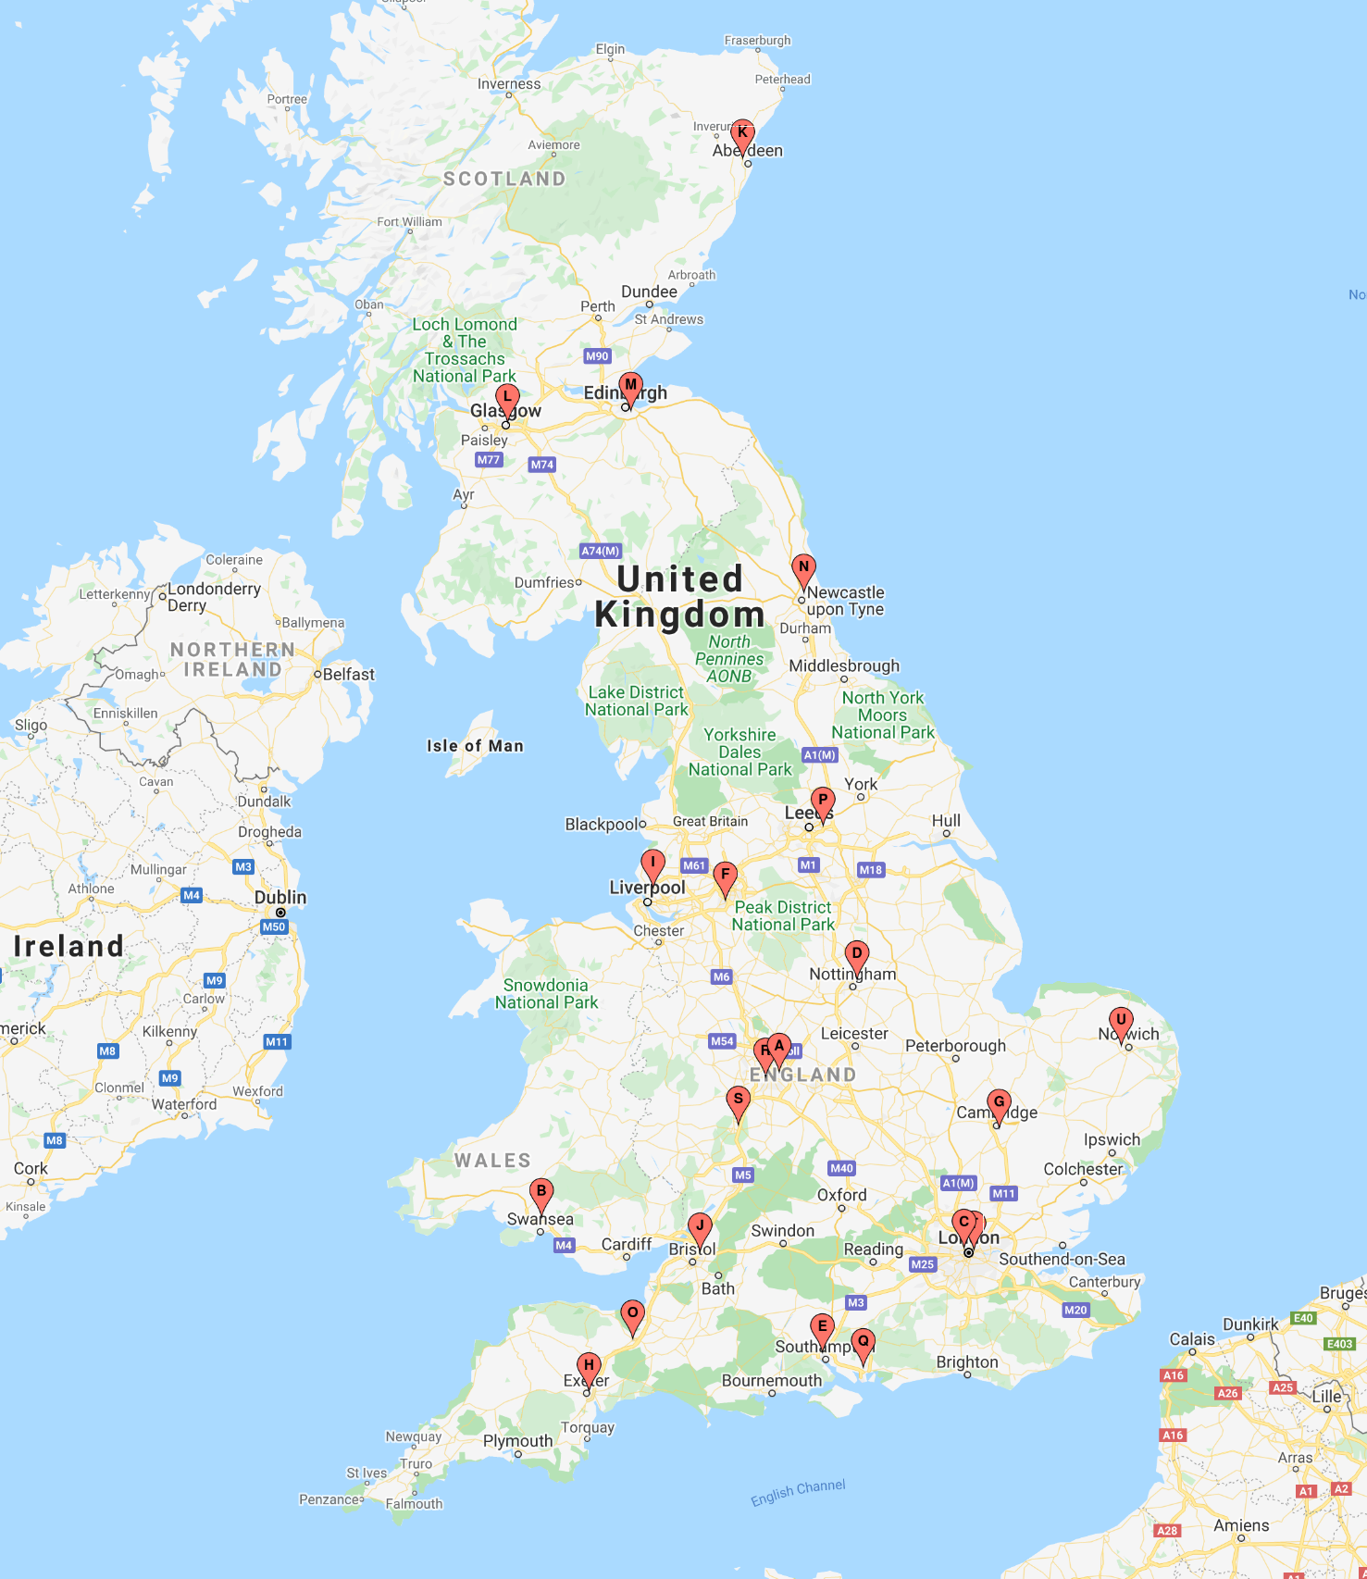

Map showing the 21 IPFJES recruiting centres

Randomly-selected control clinics for recruiting centres are shown in Table three. Where more than one clinic is shown this indicates that the random selection process was repeated because of difficulty recruiting adequate numbers of participants (defined as four attendances to the control clinic by the local research team and fewer than four participants recruited).

### Table three: centre control clinic and recruitment

|  |  |  |
| --- | --- | --- |
|  | Cases (N=494) | Controls (N=466) |
| centre number (control source clinic) |  |  |
| 1 (General Surgery) | 42 | 39 |
| 2 (Gastroenterology/Stroke) | 13 | 11 |
| 3 (Cardiology) | 38 | 36 |
| 4 (Urology) | 52 | 52 |
| 5 (Diabetes/Rheumatology) | 40 | 31 |
| 6 (Sleep Apnea) | 34 | 37 |
| 7 (Neurology) | 15 | 16 |
| 8 (ENT) | 40 | 39 |
| 9 (Rheumatology) | 31 | 29 |
| 10 (Oncology) | 21 | 731 |
| 11 (Urology) | 11 | 11 |
| 12 (Haematology) | 4 | 3 |
| 13 (Respiratory) | 13 | 14 |
| 14 (Cardiology) | 20 | 16 |
| 15 (Cardiology) | 15 | 14 |
| 16 (Orthopaedics) | 39 | 22 |
| 17 (Asthma) | 6 | 6 |
| 18 (Hypertension) | 15 | 12 |
| 19 (General Surgery) | 7 | 9 |
| 20 (Urology) | 31 | 25 |
| 21 (Respiratory) | 7 | 2 |

1 Controls were over-recruited at the local participating centre to help to achieve the recruitment target. 2 Controls were under-recruited because of local research staffing shortage.

330 (67%) cases and 295 (63%) controls ever had a high or medium asbestos exposure risk job, defined on the basis of proportional occupational mortality statistics.[124] Ever having a high or medium asbestos exposure risk job was not associated with IPF (see Table four).

### Table four: Occupational asbestos exposure (inferred by job title) and IPF risk (ever vs never)

|  |  |  |  |  |
| --- | --- | --- | --- | --- |
|  | Cases (%) | Controls (%) | Unadjusted OR (95%CI; p-value) | Adjusted OR1 (95%CI; p-value) |
| ever | 330(67) | 295(63) | 1.17(0.9-1.5; 0.28) | 1.09(0.8-1.5; 0.6) |
| never | 164(33) | 171(37) | 1 | 1 |

1 Adjusted for age, smoking, and centre

There was a non-statistically significant trend in the unadjusted OR whereby higher exposure categories had higher (non-significant) OR for disease (see Table five). Chi2 test for trend was 1.7, p=0.19.

### Table five: Occupational asbestos exposure (inferred by job title) and IPF risk (categories of exposure)

|  |  |  |  |  |
| --- | --- | --- | --- | --- |
| Category | Cases (%) | Controls (%) | Unadjusted OR (95%CI; p-value) | Adjusted OR1 (95%CI; p-value) |
| high-risk non-construction | 65(13) | 52(11) | 1.30(0.8-2.1;0.3) | 1.10(0.7-1.8; 0.7) |
| high-risk construction | 141(29) | 126(27) | 1.17(0.8-1.8;0.5) | 1.13(0.8-1.7; 0.55) |
| medium risk industrial | 124(25) | 117(25) | 1.11(0.7-1.7;0.64) | 1.06(0.7-1.6; 0.79) |
| low risk industrial | 94(19) | 98(21) | 1(0.7-1.5;0.99) | 0.94(0.6-1.5; 0.78) |
| office | 70(14) | 73(16) | 1 | 1 |

1 Adjusted for age, smoking, and centre

A total of 463 asbestos exposed job tasks were recalled in sufficient detail to permit a fibre-ml.year estimate of exposure by 233 individual participants. 125 (25%) of cases and 108 (23%) of controls recalled occupational asbestos exposure in sufficient detail to permit estimation of cumulative fibre-ml.year exposure. 41 (33%) of cases and 35 (32%) of controls which equated to approximately 8% of the total number of cases and 8% of the total number of controls, had cumulative estimates exceeding 25 asbestos fibre-ml.years (see Table six).

### Table six: Occupational asbestos exposure (cumulative fibre ml year estimate) and IPF risk

|  |  |  |  |  |  |  |  |  |
| --- | --- | --- | --- | --- | --- | --- | --- | --- |
|  | N (% total) | median | 0-4 | 5-9 | 10-14 | 15-19 | 20-24 | > 25 |
| cases | 125 (25) | 6.86 | 62 (50) | 10 (8) | 8 (6) | 3 (2) | 4 (3) | 41 (33) |
| controls | 108 (23) | 4.36 | 56 (52) | 4 (4) | 5 (5) | 0 (0) | 5 (5) | 35 (32) |

Fibre-ml.year exposure assessments showed reasonable correlation on the log-scale, but not the linear scale, with an independent assessor (JC) for a validation sample of low, medium, and high exposure assessments, R2 = 0.63 (see Figure 6.2).

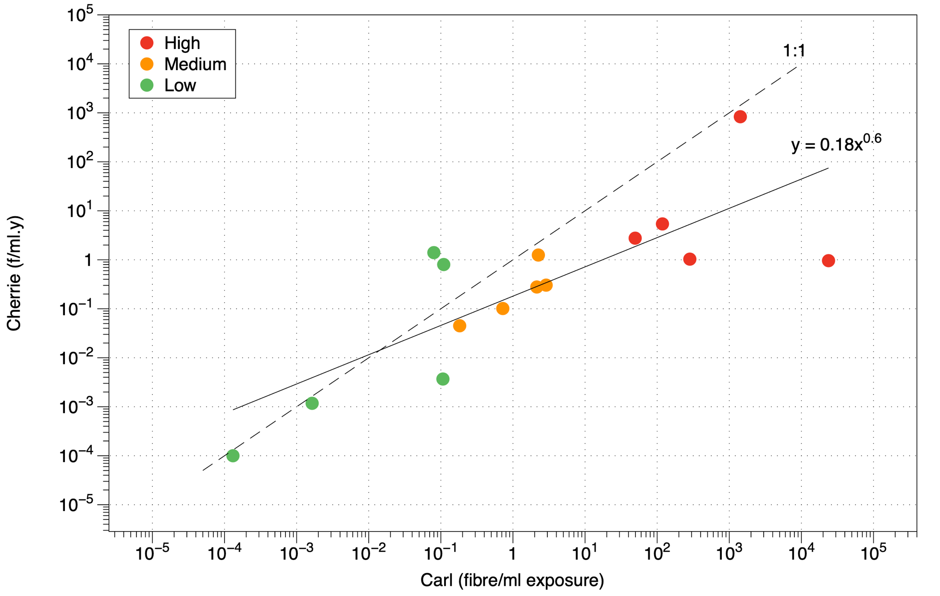

Independent validation of fibre-ml.year exposure assessments

108(23%) of 463 asbestos exposed job task fibre-ml.year estimates were in excess of 25 fibre-ml.years. 81(75%) occurred in jobs classified as high risk or medium risk; 17(15%) occurred in high-risk non-construction jobs e.g boiler lagger, 54(50%) in high-risk construction jobs such as carpenter, electrician, and plumber, and 10 (9%) in medium risk industrial jobs such as machinist or fitter. Carpenter was the single most common job title accounting for 6(5%) of estimates in excess of 25 fibre-ml.years (see Figures 6.3 and 6.4).

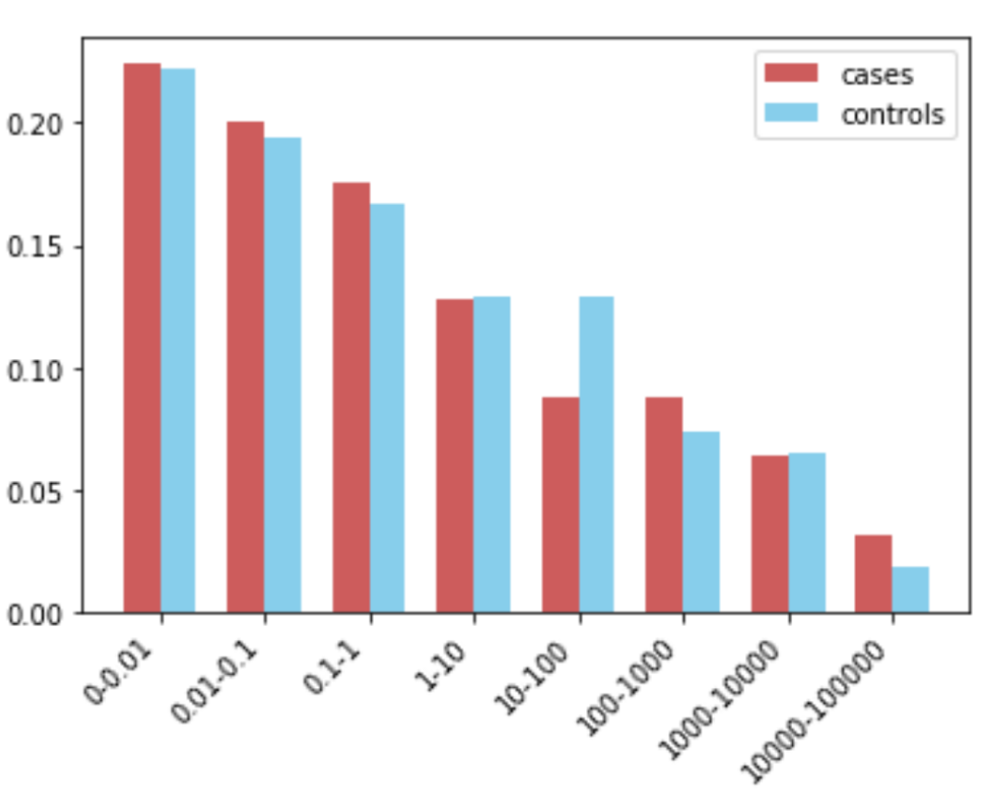

Proportion of exposed participants in fibre-ml.year categories of exposure for those reporting exposure (N=108)

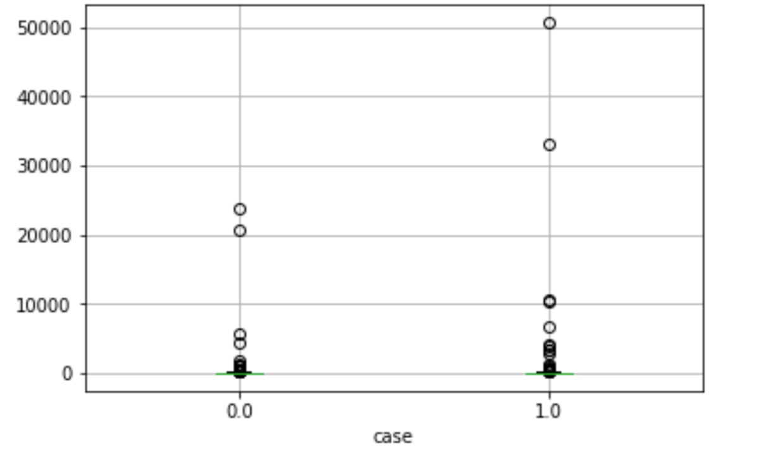

Boxplot of fibre-ml.year asbestos exposure estimates for cases and controls for those reporting exposure (N=108)

818(85%) of the 960 participants were genotyped for MUC5b rs3570950. Being heterozygous for the disease associated variant (GT) had an odds ratio of 5 (95%CI 3.7-6.8; p < 0.001) for disease. Being homozygous for the disease associated variant (GG) had an odds ratio of 13.3 (95%CI 5.1-35, p < 0.001) for disease. Ever having smoked was associated with increased risk of disease, odds ratio 1.4 (95%CI 1-1.8, p < 0.03). There was a statistically significant interaction between smoking and having ever been been exposed to a high or medium asbestos exposure risk job, odds ratio for interaction 1.9 (95%CI 1.03-3.36, p < 0.04). Several non-significant gene-environment interactions were present (see Table seven).

### Table seven: MUC5b rs35705950, occupational asbestos exposure, smoking, and IPF risk

|  |  |
| --- | --- |
| Exposure | OR (95%CI; p-value)1 2 |
| rs35705950 |  |
| GG | 1 |
| GT | 5 (3.7-6.8; < 0.001) |
| TT | 13.3 (5.1-35; < 0.001) |
|  |  |
| Ever smoked | 1.4 (1-1.8; 0.03)3 |
| EE interaction (smoking and ever exposed) | 1.9 (1.03-3.36; 0.04)3 |
|  |  |
| GE interaction (ever exposed) | 1.5 (0.8-2.7; 0.2) |
| GE interaction (categories of exposure) | 1.1(0.9-1.4; 0.38) |
| GE interaction (fibre-ml years) | 1(0.99-1; 0.34) |
| GE interaction (ever smoked) | 1.2 (0.6-2.2; 0.7) |

1 additive model, adjusted for age and smoking, N=818 for analysis involving genotype and N=960 for analysis not involving genotype  
2 adjusted for age only where smoking is exposure  
3 when adjusting for centre also ever smoked remains significant but smoking and ever exposed does not

The regression coefficient for MUC5b rs35705950 genotype, using an additive model, was significant but age, smoking, asbestos exposure, and the interaction of asbestos exposure and genotype were not. See dot-and-whisker plot of regression coefficients (Figure 6.5).

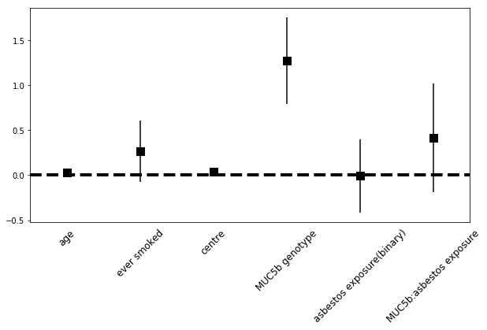

Regression coefficients for logistic regression of case status against age in years, ever having smoked (binary), centre, MUC5b rs35705950 genotype (additive model), asbestos exposure (ever held high or medium risk asbestos exposure job based on job title), and gene-environment interaction (N=818)

Ever having a job with wood, metal, or stone exposure was associated with disease, odds ratio 1.7 (95%CI 1.2-2.3, p < 0.01). Stone dust exposure alone was associated with a statistically significant odds ratio for disease of 2.9 (95%CI 1.3-6.7, p < 0.01) but wood and metal dust were not (see Table eight).

### Table eight: Occupational metal, wood, and stone exposure and IPF risk

|  |  |  |  |  |
| --- | --- | --- | --- | --- |
| Exposure | Cases (%) | Controls (%) | Unadjusted OR (95%CI; p-value) | Adjusted OR1 (95%CI; p-value) |
| Wood, metal, stone (any) | 139(28) | 84(18) | 1.8(1.3-2.4; <0.01) | 1.7(1.2-2.3; <0.01) |
| Wood | 48(10) | 31(7) | 1.5(0.9-2.4; 0.09) | 1.4(0.9-2.3; 0.2) |
| Metal | 88(18) | 57(12) | 1.6(1.1-2.2; 0.02) | 1.4(0.9-2.0; 0.1) |
| Stone | 24(5) | 8(2) | 2.9(1.3-6.6; 0.01) | 2.9(1.3-6.7; 0.01) |

1 Adjusted for age, smoking, and centre

As a result of increasing awareness, and regulation, occupational asbestos exposure prior to 1980 was significantly more widespread.[59] To investigate whether occupational asbestos exposure might be associated with IPF during this period I performed a sensitivity analysis by only including participants jobs that ended before 1980. I did not observe a significant association (Table nine and ten). I also performed sensitivity analyses limiting to jobs that started before 1980, participants born prior to 65, and considering only jobs before age 45[47]; there was no significant association between asbestos exposure and IPF for these.

### Table nine: Sensitivity analysis (limited to jobs that ended before 1980): Occupational asbestos exposure (inferred by job title) and IPF risk (ever vs never)

|  |  |  |  |  |
| --- | --- | --- | --- | --- |
|  | Cases (%) | Controls (%) | Unadjusted OR (95%CI; p-value) | Adjusted OR1 (95%CI; p-value) |
| ever | 250(62) | 220(59) | 1.11(0.8-1.5; 0.46) | 0.97(0.72-1.32; 0.87) |
| never | 156(38) | 153(41) | 1 | 1 |

1 Adjusted for age, smoking, and centre

### Table ten: Sensitivity analysis (limited to jobs that ended before 1980): Occupational asbestos exposure (inferred by job title) and IPF risk (categories of exposure)

|  |  |  |  |  |
| --- | --- | --- | --- | --- |
| Category | Cases (%) | Controls (%) | Unadjusted OR (95%CI; p-value) | Adjusted OR1 (95%CI; p-value) |
| high-risk non-construction | 53(13) | 36(10) | 1.55(0.9-2.6;0.62) | 1.09(0.61-1.94;0.77) |
| high-risk construction | 95(23) | 81(22) | 1.22(0.8-1.9;0.88) | 1.01(0.63-1.63;0.97) |
| medium risk industrial | 102(25) | 103(28) | 1.03(0.7-1.6;0.37) | 0.83(0.52-1.33;0.44) |
| low risk industrial | 90(22) | 84(23) | 1.12(0.7-1.8;0.12) | 0.94(0.58-1.52;0.8) |
| office | 66(16) | 69(18) | 1 | 1 |

1 Adjusted for age, smoking, and centre

I considered that a minimum duration in a high or medium risk job might be important and performed a sensitivity analysis limited to jobs of five or more years in duration (See Table eleven and twelve and Figure 6.6)

### Table eleven: Sensitivity analysis (limited to jobs that spent minimum of 5 years in): Occupational asbestos exposure (inferred by job title) and IPF risk (ever vs never)

|  |  |  |  |  |
| --- | --- | --- | --- | --- |
|  | Cases (%) | Controls (%) | Unadjusted OR (95%CI; p-value) | Adjusted OR1 (95%CI; p-value) |
| ever | 257(52) | 235(51) | 1.06(0.82-1.37; 0.65) | 0.93(0.71-1.22; 0.63) |
| never | 237(48) | 230(49) | 1 | 1 |

1 Adjusted for age, smoking, and centre

### Table twelve: Sensitivity analysis (limited to jobs that spent minimum of 5 years in): Occupational asbestos exposure (inferred by job title) and IPF risk (categories of exposure)

|  |  |  |  |  |
| --- | --- | --- | --- | --- |
| Category | Cases (%) | Controls (%) | Unadjusted OR (95%CI; p-value) | Adjusted OR1 (95%CI; p-value) |
| high-risk non-construction | 34(7) | 32(7) | 0.93(0.55-1.6;0.47) | 0.68(0.38-1.22;0.2) |
| high-risk construction | 115(23) | 98(22) | 1.03(0.71-1.5;0.39) | 0.94(0.64-1.4;0.78) |
| medium risk industrial | 108(22) | 105(23) | 0.9(0.63-1.3;0.26) | 0.72(0.49-1.07;0.11) |
| low risk industrial | 99(20) | 109(23) | 0.79(0.55-1.48;0.14) | 0.73(0.49-1.08;0.34) |
| office | 138(28) | 121(26) | 1 | 1 |

1 Adjusted for age, smoking, and centre

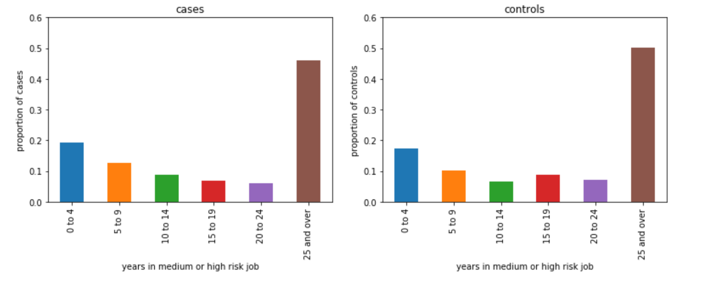

Years in a medium or high risk asbestos exposure job for cases and controls (N=492)

Cases and controls lived an average of 28km and 16km respectively from their recruiting hospital, measured by calculating the distance between the postcode centroid of the participants general practice and the postcode centroid of the hospital. Living further away from the hospital correlated with being a case, r=0.22, 95%CI = 0.16-0.29, p < 0.001 and weakly correlated with reduced asbestos exposure, r=-0.06, 95%CI = -0.13-0, p=0.05. To investigate this further I performed a sensitivity analysis limited to participants within 10km of their recruiting hospital (Table thirteen and fourteen).

### Table thirteen: Sensitivity analysis (limited to participants within 10km of the hospital): Occupational asbestos exposure (inferred by job title) and IPF risk (ever vs never)

|  |  |  |  |  |
| --- | --- | --- | --- | --- |
|  | Cases (%) | Controls (%) | Unadjusted OR (95%CI; p-value) | Adjusted OR1 (95%CI; p-value) |
| ever | 111(73) | 180(64) | 1.46(0.95-2.26; 0.08) | 1.33(0.82-2.16; 0.24) |
| never | 42(27) | 100(36) | 1 | 1 |

1 Adjusted for age, smoking, and centre

### Table fourteen: Sensitivity analysis (limited to participants within 10km of the hospital): Occupational asbestos exposure (inferred by job title) and IPF risk (categories of exposure)

|  |  |  |  |  |
| --- | --- | --- | --- | --- |
| Category | Cases (%) | Controls (%) | Unadjusted OR (95%CI; p-value) | Adjusted OR1 (95%CI; p-value) |
| high-risk non-construction | 23(15) | 35(13) | 1.62(0.75-3.51;0.22) | 1.05(0.44-2.52;0.9) |
| high-risk construction | 47(31) | 80(29) | 1.45(0.74-2.83;0.23) | 1.21(0.58-2.52;0.62) |
| medium risk industrial | 41(27) | 65(23) | 1.55(0.78-3.09;0.21) | 0.93(0.43-2.04;0.86) |
| low risk industrial | 25(16) | 58(21) | 1.06(0.51-2.21;0.87) | 0.69(0.31-1.59;0.39) |
| office | 17(11) | 42(15) | 1 | 1 |

1 Adjusted for age, smoking, and centre

To investigate cumulative ‘dose’ of exposure based on job title a score was assigned based on asbestos exposure risk category of each job as follows:

* high-risk non-construction : 2
* high-risk construction : 2
* medium risk industrial : 1
* low risk industrial : 0
* office : 0

Scores were then multiplied for each job by the duration in years of the job and then summed at participant level. See Table fifteen and Figure 6.7.

### Table fifteen: Sensitivity analyses: cumulative ‘dose’ based on occupational asbestos exposure (inferred by job title)

|  |  |  |  |  |  |  |  |  |
| --- | --- | --- | --- | --- | --- | --- | --- | --- |
|  | N | mean | std | min | 25% | 50% | 75% | max |
| cases | 494 | 23.9 | 30.8 | 0 | 0 | 9 | 40 | 126 |
| controls | 466 | 24 | 30.4 | 0 | 0 | 6.5 | 42 | 118 |

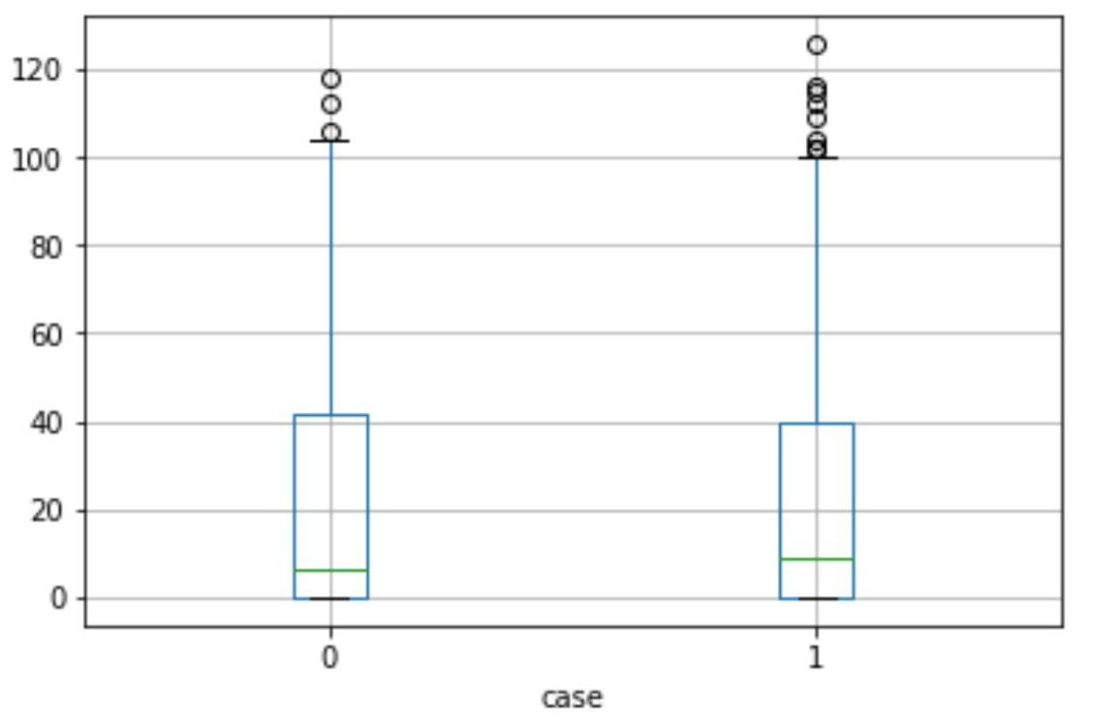

Boxplot of cumulative asbestos exposure estimates (inferred from job title) for cases and controls (N=960)

310 (63%) of IPF cases initially presented to their doctor with cough and 306 (62%) with breathlessness (91 patients presented with cough and breathlessness). 15 (3%) of cases and 42 (9%) of controls reported ever taking a medication suspected of causing usual interstitial pneumonia (amiodarone, azathioprine, bleomycin, flecainide, gefitinib, ifosamide, melphalan, and nitrofurantoin).[123]

414 (83%) of cases and 441 (95%) of controls reported one or more comorbidities. The most commonly reported comorbidities (occurring in at least 10 cases or controls) occurred at a similar frequency in cases and controls and included hypertension, type II diabetes mellitus, hypercholesterolemia, ischaemic heart disease, atrial fibrillation, COPD, osteoarthritis, and prostate cancer. Rheumatoid arthritis was reported in 18 cases, approximately 2% of cases reporting a comorbidity, and in 9 controls, approximately 1% of controls reporting a comorbidity. Gastro-oesophageal reflux disease (GORD) was reported in 14 cases, approximately 1.5% of cases reporting a comorbidity, and in 2 controls, approximately 0.5% of controls reporting a comorbidity.

Dyspnoea, as measured by the mMRC dyspnoea scale was associated with case-status, smoking status, genotype, and asbestos exposure. Pearson’s correlation coefficient for IPF was 0.49 (95%CI 0.44-0.53, p<0.001), ever smoking was 0.16 (95%CI 0.09-0.23, p<0.001), pack-year smoked was 0.2 (95%CI 0.13-0.26, p<0.001), genotype 0.2 (95%CI 0.13-0.27, p<0.001), ever held a medium or high risk asbestos exposure job title 0.09 (95%CI 0.02-0.16, p=0.02), and 0.15 (95%CI 0.08-0.21, p<0.001) for having a fibre-ml.year estimate > 25. See Table sixteen and seventeen for ordinal logistic regression results.

### Table sixteen: Ordinal logistic regression for mMRC score and ever exposed to asbestos

|  |  |  |
| --- | --- | --- |
|  | Unadjusted OR (95%CI; p-value) | Adjusted OR1 (95%CI; p-value) |
| case | 6.94(5.38-9; <0.001) | 6.8 (5.25-8.8; <0.001) |
| pack-years | 1.01(1-1.02;<0.001) | 1.02(1.01-1.02; <0.001) |
| ever exposed2 | 1.48(1.17-1.87; <0.001) | 1.44(1.12-1.84; 0.004) |

1 Adjusted for age, smoking (pack-years), and case status 2 Ever exposed to a high or medium asbestos exposure job (inferred from job title)

### Table seventeen: Ordinal logistic regression for mMRC score and for categories of asbestos exposure

|  |  |  |
| --- | --- | --- |
| Category | Unadjusted OR (95%CI;p-value) | Adjusted OR1 (95%CI;p-value) |
| high-risk non-construction | 2.21(1.43-3.44;<0.001) | 1.92(1.2-3.03;0.006) |
| high-risk construction | 1.9(1.31-2.74;0.001) | 1.89(1.29-2.78;0.001) |
| medium risk industrial | 1.36(0.94-1.98;0.103) | 1.28(0.87-1.89;0.21) |
| low risk industrial | 1.29(0.88-1.9;0.19) | 1.24(0.82-1.87;0.29) |
| office | 1 | 1 |

1 Adjusted for age, smoking (pack-years), and case status

Among the 818 genotyped participants MUC5b rs35705950 minor allele frequency (MAF) was 35% in cases (N=395) and 12% in controls (N=423). Subsets of genotyped cases with asbestos and smoking exposure had higher MAFs then did genotyped cases who had exposure to asbestos or smoking alone. See Table eighteen.

### Table eighteen: rs35705950 MAF for cases, case subsets, and controls (N) 1

|  |  |  |  |  |  |  |  |
| --- | --- | --- | --- | --- | --- | --- | --- |
|  | IPF (395) | IPF smoker (299) | IPF asbestos exposed (267) | IPF >25 fml-yrs (35) | IPF asbestos exposed AND smoker (214) | IPF >25 fml-yrs AND smoker (27) | Hospital controls (423) |
| GG | 152 | 112 | 101 | 11 | 76 | 9 | 327 |
| GT | 212 | 161 | 142 | 20 | 117 | 15 | 91 |
| TT | 31 | 26 | 24 | 4 | 21 | 3 | 5 |
| MAF | 35 | 36 | 36 | 40 | 37 | 39 | 12 |

1 Genotype of MUC5Brs35705950, T is minor allele. MAF is minor allele frequency (%).

A history of ever having smoked and ever having had a high or medium risk job for asbestos exposure was associated with increased risk of IPF when participants also had the minor allele of MUC5b rs35705950, OR 4.6(1.5-14, p=0.01). No significant risk was observed for ever smoking or ever being asbestos exposed alone when stratifying for genotype. See Table nineteen, twenty, and twenty-one.

### Table nineteen: Logistic regression of ever smoking and ever exposed to occupational asbestos (inferred by job title) stratified by MUC5B rs35705950 genotype

|  |  |
| --- | --- |
| Exposure | OR (95% CI; p-value)1 2 |
| Ever smoker and ever asbestos exposed (all) | 1.73 (0.91-3.3, 0.09) |
| Ever smoker and ever asbestos exposed, GT or TT3 | 4.6 (1.5-14, 0.01) |
| Ever smoker and ever asbestos exposed, GG3 | 0.94 (0.38-2.3, 0.9) |

1 additive model, adjusted for age and smoking 2 analysis limited to genotyped participants (N=818) 3 Genotype of MUC5B rs35705950, T is minor allele

### Table twenty: Logistic regression of ever smoking stratified by MUC5B rs35705950 genotype

|  |  |
| --- | --- |
| Exposure | OR (95% CI; p-value)1 2 |
| Ever smoker (all) | 1.45 (1.06-1.99, 0.02) |
| Ever smoker, GT or TT3 | 1.66 (0.97-2.84, 0.06) |
| Ever smoker, GG3 | 1.27 (0.83-1.96, 0.28) |

1 additive model, adjusted for age 2 analysis limited to genotyped participants (N=818) 3 Genotype of MUC5B rs35705950, T is minor allele

### Table twenty-one: Logistic regression of ever having been exposed to occupational asbestos (inferred by job title) stratified by MUC5B rs35705950 genotype

|  |  |
| --- | --- |
| Exposure | OR (95% CI; p-value)1 2 |
| Ever asbestos exposed (all) | 1.17 (0.88-1.57, 0.29) |
| Ever asbestos exposed, GT or TT3 | 1.62 (0.99-2.64, 0.06) |
| Ever asbestos exposed, GG3 | 1.02 (0.68-1.53, 0.94) |

1 additive model, adjusted for age and smoking 2 analysis limited to genotyped participants (N=818) 3 Genotype of MUC5B rs35705950, T is minor allele

## Discussion

### findings, interpretation, implications, relations ot others work, limitations, strengths

494 cases and 466 controls were recruited and interviewed. The median age of cases was 76 years and controls 74 years. 97% of cases and 96% of controls reported their ethnicity as white and social economic class and exposure to smoking were similar for cases and controls (see Table 1). Cases were less likely than controls to have ever been prescribed medications known to cause UIP, 15(3%) versus 42(9%) respectively. Cases were more likely than controls to be breathless, Pearson’s correlation coefficient for mMRC dyspnoea and case status was 0.49 (95%CI 0.44-0.53, p<0.001), adjusted OR for was 6.8 (95%CI 5.25-8.8; p<0.001). Cases were also more likely to have gastro-oesophageal reflux disease than controls, 14(2%) versus 2(0.5%), a known association.[125] After controlling for case and smoking status being ever exposed to a high or medium asbestos exposure risk job was associated with dyspnoea, measured using ordinal logistic regression and mMRC dyspnoea score, OR 1.44(1.12-1.84; p=0.004). The strength of association between asbestos exposure and dyspnoea increased with increasing categories of asbestos exposure risk.

Ever being exposed to an occupation with high or medium risk for asbestos exposure was common for both cases (67%) and controls (63%) and the difference in the proportion ever exposed between cases and controls was not significant (Table four). A similar pattern was observed for categories of exposure (Table five). 8% of cases and controls had estimated cumulative asbestos fibre-ml.year exposures in excess of 25 fibre-ml.years, the Helsinki criteria exposure threshold at which cases of asbestosis may occur.[54] The majority of these participants had high or medium risk occupations as defined by job title with carpenter being the single most common job title accounting for 5% of all estimates in excess of 25 fibre-ml.years. We found a significant association with occupational exposure to stone dust and IPF, OR 2.9(1.3-6.7; 0.01).

In common with numerous previous studies we found MUC5b rs3570950 to be strongly associated with disease in a risk allele dose-dependant fashion. We found no evidence of interaction between asbestos exposure MUC5b rs3570950. However, we did find a significant association for having ever smoked, OR 1.4 (95%CI 1-1.8, p < 0.03) and for having ever smoked and having ever had a high or medium asbestos exposure risk based on job title, OR 1.9 (95%CI 1.03-3.36, p < 0.04). Sensitivity analyses including limiting jobs considered to only those that ended before 1980, considering only jobs with a duration greater than 5 years, considering only participants living within 10km of their recruiting hospital, and considering cumulative exposure ‘dose’ based on summing years in different asbestos exposure risk categories (assigned by job title) at participant level, were all non-significant.

Cases and controls were well matched and there was no significant association between asbestos exposure, measured by well validated means by job title or by historic asbestos exposure reconstruction, and IPF. There are three main possible explanations for this:

1. Asbestos exposure is not an important cause of IPF
2. Asbestos exposure is only an important cause in concert with other environmental or genetic exposures
3. Asbestos exposure has not been measured accurately enough in IPFJES

8% of cases apparently meet the Helsinki criteria for a diagnosis of asbestosis.[54] This criterion has been criticised for failing to reflect the linear dose-response relationship, and lack of threshold, observed in the published literature.[126][127][56] Strictly, IPF is a diagnosis of exclusion that should not be made until exposures to asbestos, and other known causes of fibrosis, have been excluded.[122][56] Taken to its logical conclusion this line of argument may result in no diagnoses of IPF in the UK since asbestos exposure is ubiquitous; the average asbestos lung burden in men and women without occupational asbestos exposure was recently measured at approximately 1 fibre/mg of lung tissue.[59] In IPFJES the population attributable fraction (PAF) calculated using the adjusted, non-significant, odds ratio (OR) for ever exposed and proportion of cases ever exposed (pc) and the equation: PAF = pc(OR − 1)/OR[22] is about 5%.

Of note asbestosis is not necessarily fatal[128] and may not even be symptomatic since diagnostic criteria require evidence of scarring of the lungs and evidence of asbestos exposure but not the presence of symptoms.[54] In this context a cut off below which exposure is unlikely to cause significant morbidity or mortality seems reasonable. Intriguingly our results support the concept of asbestos exposure being associated with dyspnoea independent of having IPF and smoking status.

In epidemiological studies the death rate from asbestosis and prevalence of signs and symptoms to it are both higher in cigarette smokers than non-smokers.[128] In mouse studies cigarette smoke and asbestos exposure increase the production of reactive oxygen species that are thought to be important in the pathogenesis of asbestosis.[129] Asbestos fibres activates Nalp3 inflammasomes and cigarette smoke is thought to attenuate the innate immune response to asbestos through Nalp3 inflammasome suppression.[130] This is compatible with our observation of an interaction between asbestos exposure, as measured by ever having a job at medium or high risk for asbestos exposure, and ever having smoked on IPF risk, OR 1.9 (95%CI 1.03-3.36, p=0.04).

There is a precedent for the importance of genetic susceptibility in the development of disease in response to asbestiform fibre inhalation; specifically germline BAP1 mutations were discovered to be important together with eronite exposure in the Cappodecia mesothelioma epidemic.[131][132] It is possible that there unmeasured genetic modifiers of asbestos exposure risk the presence, or absence, of which is necessary for the development of disease.

Despite best efforts it is still theoretically possible that my asbestos exposure measure was insufficiently sensitive. Review of all occupational histories by a trained occupational hygeinist blind to the case status of participants would have been desirable but was was prohibitively expensive. It is also possible that the underlying data on which to base historic assessments is not detailed enough to permit sufficiently sensitive assessments by any means.

Asbestosis can have a latency of upwards of 40 years[133] and rates have not yet peaked in the UK.[134] From 1900 until around 1960 (see Figure 6.8), when asbestos consumption in the United Kingdom peaked, the United Kingdom had the third highest per capita asbestos consumption in the world with only to the United States and later Australia having higher rates of consumption.[135] Our results are likely to generalize well globally where, with the exception of Brasil, Russian, India, Iran, and China which continue to consume asbestos, consumption has been lower and peaked later.

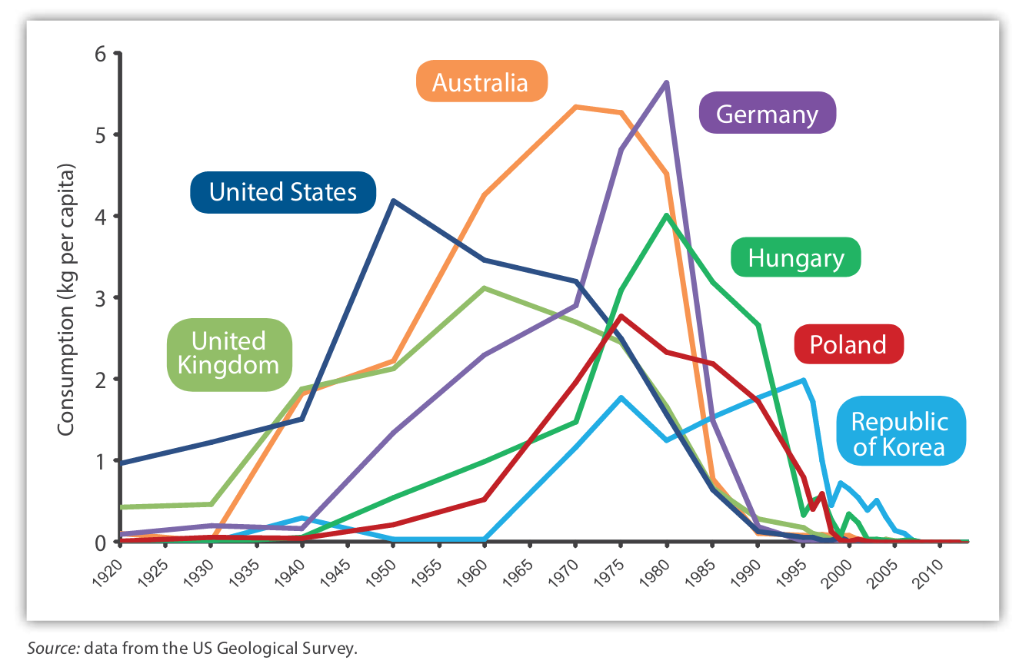

Global asbestos consumption per capita 1920-2013

The main strengths of our study include its size, use of hospital controls, high participation rates and avoidance of non-response bias, the use of two independent validated asbestos exposure assessment instruments, and the assessment of gene-environment interaction. Additionally assessors in IPFJES were blind to case status throughout and the study design and pre-specified outcomes were recorded on clincialtrial.gov (NCT03211507).

## Conclusion

The majority of men in their 70s in the UK who attend hospital have held a high or medium risk for asbestos exposure job during their working lifetime; estimated asbestos exposure based on validated means inferred by job title or historic asbestos exposure reconstruction methods does not significantly affect risk of IPF. Nonetheless, about 8% of IPF cases have a history of heavy occupational asbestos exposure (>25 fibre-ml.years) that would support a diagnosis of asbestosis based on the Helsinki criteria.

Asbestos exposure alone does not appear to be an important cause of IPF. It remains possible that it is important in concert with other, unmeasured, environmental or genetic risk factors, and is associated with dyspnoea in our study.

# Conclusion

## Thesis summary

This thesis presents the findings of an analysis of UK mortality trends for IPF and asbestos related disease, a review of previous occupational case-control studies of IPF that have investigated occupational exposures in IPF, a review of historic asbestos exposure assessment methods, a review of the IPF genetic susceptibility factor MUC5b promotor region SNP rs35705950, and the idiopathic pulmonary fibrosis job exposures study (IPFJES).

IPF mortality and asbestos related disease are strongly, if ecologically, correlated and there are several prima facae reasons to suppose that occupational asbestos exposure is an under-recognised cause of IPF, namely: it is more common in men and manual workers, it has been associated with occupational metal, wood, and stone dust exposures in several previous studies, and heavy asbestos fibre burdens have been identified in the lung tissue of IPF patients in a small case series.

Historic asbestos exposure assessment is challenging because of a paucity of historic data and variable biopersistence and invitro modification of asbestos fibres. Among the best current validated means are assessment based on job title and the use of known job title related pleural mesothelioma risk as a proxy, and historic exposure reconstruction using source receptor models that provide validated estimates of cumulative asbestos exposure.

The MUC5b promotor region SNP rs357950 is the strongest identified risk factor for IPF. It is associated with higher levels of distal airway MUC5b and is thought to mediate disease by reduced airway clearance and through interaction with airway microbiota.

IPFJES, a large multicentre hospital based case-control study of occupational exposures in IPF, demonstrates that the majority of men in the UK have at least one high or medium risk for asbestos exposure job during their lifetime and about 8% have heavy (>25 fibre-ml.year) asbestos exposure, that this is not significantly associated with IPF risk, and that this association is not modified by rs357950 genotype. IPFJES finds a significant association between occupational asbestos exposure and dyspnoea which is independent of case and smoking status.

## Future work

Planned future work includes further study of non-asbestos occupational exposures in IPF, augmentation of the study data with pulmonary function test measurements, a mendelian randomisation study of smoking in IPF, and antibody characterisation of serum collected from participants with a view to investigating the possibility of chronic hypersensitivity pneumonitis IPF misclassification.

# Appendix 1: IPF epidemiology code

[IPF epidemiology](https://github.com/drcjar/pypf)

# Appendix 2: IPFJES study documentation

[IPFJES study documentation](https://github.com/drcjar/ipfjes/)

# References

1 Navaratnam V, Fleming K, West J *et al.* The rising incidence of idiopathic pulmonary fibrosis in the uk. *Thorax* 2011;**66**:462–7.

2 Navaratnam V, Hubbard RB. The mortality burden of idiopathic pulmonary fibrosis in the united kingdom. *American journal of respiratory and critical care medicine* 2019;**200**:256–8. doi:[10.1164/rccm.201902-0467LE](https://doi.org/10.1164/rccm.201902-0467LE)

3 Maher TM. Idiopathic pulmonary fibrosis: Pathobiology of novel approaches to treatment. *Clin Chest Med* 2012;**33**:69–83. doi:[10.1016/j.ccm.2011.11.002](https://doi.org/10.1016/j.ccm.2011.11.002)

4 Ley B, Collard HR. Epidemiology of idiopathic pulmonary fibrosis. *Clinical epidemiology* 2013;**5**:483.

5 Spagnolo P, Grunewald J, Bois RM du. Genetic determinants of pulmonary fibrosis: Evolving concepts. *The Lancet Respiratory Medicine* 2014;**2**:416–28.

6 Hutchinson JP, McKeever TM, Fogarty AW *et al.* Increasing global mortality from idiopathic pulmonary fibrosis in the twenty-first century. *Annals of the American Thoracic Society* 2014;**11**:1176–85. doi:[10.1513/AnnalsATS.201404-145OC](https://doi.org/10.1513/AnnalsATS.201404-145OC)

7 Hubbard R, Johnston I, Britton J. Survival in patients with cryptogenic fibrosing alveolitis a population-based cohort study. *CHEST Journal* 1998;**113**:396–400.

8 Vancheri C, Failla M, Crimi N *et al.* Idiopathic pulmonary fibrosis: A disease with similarities and links to cancer biology. *Eur Respir J* 2010;**35**:496–504. doi:[10.1183/09031936.00077309](https://doi.org/10.1183/09031936.00077309)

9 Barber C, Wiggans R, Young C *et al.* UK asbestos imports and mortality due to idiopathic pulmonary fibrosis. *Occup Med* 2015;kqv142.

10 Corrin B, Dewar A, Rodriguez-Roisin R *et al.* Fine structural changes in cryptogenic fibrosing alveolitis and asbestosis. *The Journal of pathology* 1985;**147**:107–19. doi:[10.1002/path.1711470206](https://doi.org/10.1002/path.1711470206)

11 Copley SJ, Wells AU, Sivakumaran P *et al.* Asbestosis and idiopathic pulmonary fibrosis: Comparison of thin-section ct features. *Radiology* 2003;**229**:731–6. doi:[10.1148/radiol.2293020668](https://doi.org/10.1148/radiol.2293020668)

12 Monso E, Tura JM, Marsal M *et al.* Mineralogical microanalysis of idiopathic pulmonary fibrosis. *Arch Environ Health* 1990;**45**:185–8. doi:[10.1080/00039896.1990.9936714](https://doi.org/10.1080/00039896.1990.9936714)

13 Monsó E, Tura J, Pujadas J *et al.* Lung dust content in idiopathic pulmonary fibrosis: A study with scanning electron microscopy and energy dispersive x ray analysis. *Br J Ind Med* 1991;**48**:327–31.

14 Glazer C, Maier L. Occupational interstitial lung disease. *Eur Respir Monograph* 2009;**46**:265–86.

15 Ghio A, Sangani R, Roggli V. Expanding the spectrum of particle-and fiber-associated interstitial lung diseases. *Turk Toraks Derg* 2014;**15**:1–8.

16 Travis WD, Costabel U, Hansell DM *et al.* An official american thoracic society/european respiratory society statement: Update of the international multidisciplinary classification of the idiopathic interstitial pneumonias. *American journal of respiratory and critical care medicine* 2013;**188**:733–48.

17 Reynolds CJ, Blanc PD. Organising pneumonia and other uncommon interstitial disorders. In: *Parkes’ occupational lung disorders, fourth edition*. 2018.

18 Turner-Warwick M. In search of a cause of cryptogenic fibrosing alveolitis (cfa): One initiating factor or many? *Thorax* 1998;**53**:S3–9.

19 Hubbard R. Occupational dust exposure and the aetiology of cryptogenic fibrosing alveolitis. *Eur Respir J* 2001;**18**:119s–21s.

20 Taskar VS, Coultas DB. Is idiopathic pulmonary fibrosis an environmental disease? *Proc Am Thorac Soc* 2006;**3**:293–8.

21 Gulati M, Redlich CA. Asbestosis and environmental causes of usual interstitial pneumonia. *Current opinion in pulmonary medicine* 2015;**21**:193–200. doi:[10.1097/MCP.0000000000000144](https://doi.org/10.1097/MCP.0000000000000144)

22 Blanc PD, Annesi-Maesano I, Balmes JR *et al.* The occupational burden of nonmalignant respiratory diseases. an official american thoracic society and european respiratory society statement. *American journal of respiratory and critical care medicine* 2019;**199**:1312–34. doi:[10.1164/rccm.201904-0717ST](https://doi.org/10.1164/rccm.201904-0717ST)

23 Fontaine J-F, Barbosa-Silva A, Schaefer M *et al.* MedlineRanker: Flexible ranking of biomedical literature. *Nucleic acids research* 2009;**37**:W141–6. doi:[10.1093/nar/gkp353](https://doi.org/10.1093/nar/gkp353)

24 Reynolds C, De Matteis S, Cullinan P *et al.* Pubmed mining for occupational idiopathic pulmonary fibrosis papers. 2017.

25 Pega F, Norris SL, Backes C *et al.* RoB-speo: A tool for assessing risk of bias in studies estimating the prevalence of exposure to occupational risk factors from the who/ilo joint estimates of the work-related burden of disease and injury. *Environment international* 2020;**135**:105039. doi:[10.1016/j.envint.2019.105039](https://doi.org/10.1016/j.envint.2019.105039)

26 Scott J, Johnston I, Britton J. What causes cryptogenic fibrosing alveolitis? A case-control study of environmental exposure to dust. *BMJ* 1990;**301**:1015.

27 Iwai K, Mori T, Yamada N *et al.* Idiopathic pulmonary fibrosis. epidemiologic approaches to occupational exposure. *Am J Respir Crit Care Med* 1994;**150**:670–5. doi:[10.1164/ajrccm.150.3.8087336](https://doi.org/10.1164/ajrccm.150.3.8087336)

28 Hubbard R, Lewis S, Richards K *et al.* Occupational exposure to metal or wood dust and aetiology of cryptogenic fibrosing alveolitis. *The Lancet* 1996;**347**:284–9.

29 Mullen J, Hodgson MJ, DeGraff CA *et al.* Case-control study of idiopathic pulmonary fibrosis and environmental exposures. *J Occup Environ Med* 1998;**40**:363–7.

30 Baumgartner KB, Samet JM, Coultas DB *et al.* Occupational and environmental risk factors for idiopathic pulmonary fibrosis: A multicenter case-control study. collaborating centers. *Am J Epidemiol* 2000;**152**:307–15.

31 Hubbard R, Cooper M, Antoniak M *et al.* Risk of cryptogenic fibrosing alveolitis in metal workers. *The Lancet* 2000;**355**:466–7.

32 Miyake Y, Sasaki S, Yokoyama T *et al.* Occupational and environmental factors and idiopathic pulmonary fibrosis in japan. *Ann Occup Hyg* 2005;**49**:259–65.

33 Gustafson T, Dahlman-Höglund A, Nilsson K *et al.* Occupational exposure and severe pulmonary fibrosis. *Respir Med* 2007;**101**:2207–12.

34 Pinheiro GA, Antao VC, Wood JM *et al.* Occupational risks for idiopathic pulmonary fibrosis mortality in the united states. *Int J Occup Environ Health* 2008;**14**:117–23.

35 García-Sancho Figueroa MC, Carrillo G, Pérez-Padilla R *et al.* Risk factors for idiopathic pulmonary fibrosis in a mexican population. a case-control study. *Respir Med* 2010;**104**:305–9.

36 García-Sancho C, Buendía-Roldán I, Fernández-Plata MR *et al.* Familial pulmonary fibrosis is the strongest risk factor for idiopathic pulmonary fibrosis. *Respiratory medicine* 2011;**105**:1902–7. doi:[10.1016/j.rmed.2011.08.022](https://doi.org/10.1016/j.rmed.2011.08.022)

37 Awadalla NJ, Hegazy A, Elmetwally RA *et al.* Occupational and environmental risk factors for idiopathic pulmonary fibrosis in egypt: A multicenter case-control study. *Int J Occup Environ Med* 2012;**3**:107–16.

38 Paolocci G, Nicolic V, Folletti I *et al.* Risk factors for idiopathic pulmonary fibrosis in southern europe: A case-control study. 2013.

39 Ekstrom M, Gustafson T, Boman K *et al.* Effects of smoking, gender and occupational exposure on the risk of severe pulmonary fibrosis: A population-based case-control study. *BMJ open* 2014;**4**:e004018.

40 Koo J-W, Myong J-P, Yoon H-K *et al.* Occupational exposure and idiopathic pulmonary fibrosis: A multicentre case-control study in korea. *The international journal of tuberculosis and lung disease : the official journal of the International Union against Tuberculosis and Lung Disease* 2017;**21**:107–12. doi:[10.5588/ijtld.16.0167](https://doi.org/10.5588/ijtld.16.0167)

41 Paolocci G, Folletti I, Torén K *et al.* Occupational risk factors for idiopathic pulmonary fibrosis in southern europe: A case-control study. *BMC pulmonary medicine* 2018;**18**:75. doi:[10.1186/s12890-018-0644-2](https://doi.org/10.1186/s12890-018-0644-2)

42 Hubbard R, Johnston I, Coultas DB *et al.* Mortality rates from cryptogenic fibrosing alveolitis in seven countries. *Thorax* 1996;**51**:711–6.

43 Navaratnam V, Fogarty AW, McKeever T *et al.* Presence of a prothrombotic state in people with idiopathic pulmonary fibrosis: A population-based case-control study. *Thorax* 2014;**69**:207–15. doi:[10.1136/thoraxjnl-2013-203740](https://doi.org/10.1136/thoraxjnl-2013-203740)

44 Welch LS, Michaels D, Zoloth SR. The national sheet metal worker asbestos disease screening program: Radiologic findings. national sheet metal examination group. *Am J Ind Med* 1994;**25**:635–48.

45 Rake C, Gilham C, Hatch J *et al.* Occupational, domestic and environmental mesothelioma risks in the british population: A case-control study. *Br J Cancer* 2009;**100**:1175–83. doi:[10.1038/sj.bjc.6604879](https://doi.org/10.1038/sj.bjc.6604879)

46 Caminati A, Madotto F, Cesana G *et al.* Epidemiological studies in idiopathic pulmonary fibrosis: Pitfalls in methodologies and data interpretation. *European respiratory review : an official journal of the European Respiratory Society* 2015;**24**:436–44. doi:[10.1183/16000617.0040-2015](https://doi.org/10.1183/16000617.0040-2015)

47 Darnton A, Hodgson J, Benson P *et al.* Mortality from asbestosis and mesothelioma in britain by birth cohort. *Occup Med* 2012;**62**:549–52.

48 Wells AU. The revised ATS/ERS/JRS/ALAT diagnostic criteria for idiopathic pulmonary fibrosis (IPF)-practical implications. *Respir Res* 2013;**14**:S2.

49 Mossman BT, Lippmann M, Hesterberg TW *et al.* Pulmonary endpoints (lung carcinomas and asbestosis) following inhalation exposure to asbestos. *Journal of Toxicology and Environmental Health, Part B* 2011;**14**:76–121.

50 De Vuyst P, Karjalainen A, Dumortier P *et al.* Guidelines for mineral fibre analyses in biological samples: Report of the ers working group. european respiratory society. *The European respiratory journal* 1998;**11**:1416–26.

51 Cherrie JW, Schneider T. Validation of a new method for structured subjective assessment of past concentrations. *Ann Occup Hyg* 1999;**43**:235–45.

52 Nemery B, Nuyts V, Nackaerts K. Quantifying asbestos in lung tissue: What debate? *The European respiratory journal* 2017;**49**. doi:[10.1183/13993003.00861-2017](https://doi.org/10.1183/13993003.00861-2017)

53 Cooke WE. FIBROSIS of the lungs due to the inhalation of asbestos dust. *British medical journal* 1924;**2**:147–140.2.

54 Wolff H, Vehmas T, Oksa P *et al.* Asbestos, asbestosis, and cancer, the helsinki criteria for diagnosis and attribution 2014: Recommendations. *Scandinavian journal of work, environment & health* 2015;**41**:5–15. doi:[10.5271/sjweh.3462](https://doi.org/10.5271/sjweh.3462)

55 Hammar SP, Abraham JL. Commentary on pathologic diagnosis of asbestosis and critique of the 2010 asbestosis committee of the college of american pathologists (cap) and pulmonary pathology society’s (pps) update on the diagnostic criteria for pathologic asbestosis. *American journal of industrial medicine* 2015;**58**:1034–9. doi:[10.1002/ajim.22512](https://doi.org/10.1002/ajim.22512)

56 Baur X, Frank AL, Budnik LT *et al.* Collegium ramazzini: Comments on the 2014 helsinki consensus report on asbestos. *American journal of industrial medicine* 2016;**59**:591–4. doi:[10.1002/ajim.22595](https://doi.org/10.1002/ajim.22595)

57 Baur X, Woitowitz H-J, Budnik LT *et al.* Asbestos, asbestosis, and cancer: The helsinki criteria for diagnosis and attribution. critical need for revision of the 2014 update. *American journal of industrial medicine* 2017;**60**:411–21. doi:[10.1002/ajim.22709](https://doi.org/10.1002/ajim.22709)

58 Gilham C, Rake C, Burdett G *et al.* Pleural mesothelioma and lung cancer risks in relation to occupational history and asbestos lung burden. *Occupational and environmental medicine* 2016;**73**:290–9. doi:[10.1136/oemed-2015-103074](https://doi.org/10.1136/oemed-2015-103074)

59 Gilham C, Rake C, Hodgson J *et al.* Past and current asbestos exposure and future mesothelioma risks in britain: The inhaled particles study (tips). *International Journal of Epidemiology* 2018.

60 Nuyts V, Vanhooren H, Begyn S *et al.* Asbestos bodies in bronchoalveolar lavage in the 21st century: A time-trend analysis in a clinical population. *Occupational and environmental medicine* 2017;**74**:59–65. doi:[10.1136/oemed-2016-103710](https://doi.org/10.1136/oemed-2016-103710)

61 Burns D, Beaumont P. The hse national exposure database—(NEDB). *The Annals of occupational hygiene* 1989;**33**:1–14.

62 Orlowski E, Audignon-Durand S, Goldberg M *et al.* EV@LUTIL: An open access database on occupational exposures to asbestos and man-made mineral fibres. *American journal of industrial medicine* 2015;**58**:1059–74. doi:[10.1002/ajim.22498](https://doi.org/10.1002/ajim.22498)

63 Peto J. Problems in dose response and risk assessment: The example of asbestos. In: *Epidemiology and quantitation of environmental risk in humans from radiation and other agents*. Springer 1985. 175–85.

64 Toxic Substances A for, (ATSDR). DR. Agency for toxic substances and disease registry (atsdr). 2001. toxicological profile for asbestos. U.S. Department of Health; Human Services, Public Health Service. 2001. <https://www.atsdr.cdc.gov/toxprofiles/TP.asp?id=30&tid=4#bookmark16>

65 Smith TJ, Hammond SK, Hallock M *et al.* Exposure assessment for epidemiology: Characteristics of exposure. *Applied Occupational and Environmental Hygiene* 1991;**6**:441–7.

66 Sahmel J, Devlin K, Paustenbach D *et al.* The role of exposure reconstruction in occupational human health risk assessment: Current methods and a recommended framework. *Critical reviews in toxicology* 2010;**40**:799–843. doi:[10.3109/10408444.2010.501052](https://doi.org/10.3109/10408444.2010.501052)

67 Blake CL, Dotson GS, Harbison RD. Assessment of airborne asbestos exposure during the servicing and handling of automobile asbestos-containing gaskets. *Regulatory toxicology and pharmacology : RTP* 2006;**45**:214–22. doi:[10.1016/j.yrtph.2006.04.007](https://doi.org/10.1016/j.yrtph.2006.04.007)

68 Williams PRD, Phelka AD, Paustenbach DJ. A review of historical exposures to asbestos among skilled craftsmen (1940-2006). *Journal of toxicology and environmental health Part B, Critical reviews* 2007;**10**:319–77. doi:[10.1080/10937400601034191](https://doi.org/10.1080/10937400601034191)

69 Pannett B, Coggon D, Acheson ED. A job-exposure matrix for use in population based studies in england and wales. *British journal of industrial medicine* 1985;**42**:777–83.

70 Peters S, Vermeulen R, Cassidy A *et al.* Comparison of exposure assessment methods for occupational carcinogens in a multi-centre lung cancer case-control study. *Occupational and environmental medicine* 2011;**68**:148–53. doi:[10.1136/oem.2010.055608](https://doi.org/10.1136/oem.2010.055608)

71 Offermans NSM, Vermeulen R, Burdorf A *et al.* Comparison of expert and job-exposure matrix-based retrospective exposure assessment of occupational carcinogens in the netherlands cohort study. *Occupational and environmental medicine* 2012;**69**:745–51. doi:[10.1136/oemed-2011-100556](https://doi.org/10.1136/oemed-2011-100556)

72 Kauppinen T, Toikkanen J, Pukkala E. From cross-tabulations to multipurpose exposure information systems: A new job-exposure matrix. *American journal of industrial medicine* 1998;**33**:409–17.

73 Offermans NSM, Vermeulen R, Burdorf A *et al.* Occupational asbestos exposure and risk of pleural mesothelioma, lung cancer, and laryngeal cancer in the prospective netherlands cohort study. *Journal of occupational and environmental medicine* 2014;**56**:6–19. doi:[10.1097/JOM.0000000000000060](https://doi.org/10.1097/JOM.0000000000000060)

74 Oyen SC van, Peters S, Alfonso H *et al.* Development of a job-exposure matrix (asbjem) to estimate occupational exposure to asbestos in australia. *The Annals of occupational hygiene* 2015;**59**:737–48. doi:[10.1093/annhyg/mev017](https://doi.org/10.1093/annhyg/mev017)

75 Peters S, Vermeulen R, Portengen L *et al.* SYN-jem: A quantitative job-exposure matrix for five lung carcinogens. *The Annals of occupational hygiene* 2016;**60**:795–811. doi:[10.1093/annhyg/mew034](https://doi.org/10.1093/annhyg/mew034)

76 Cherrie JW, McElvenny D, Blyth KG. Estimating past inhalation exposure to asbestos: A tool for risk attribution and disease screening. *International journal of hygiene and environmental health* 2018;**221**:27–32. doi:[10.1016/j.ijheh.2017.09.013](https://doi.org/10.1016/j.ijheh.2017.09.013)

77 Ahrens W, Jöckel KH, Brochard P *et al.* Retrospective assessment of asbestos exposure–I. case-control analysis in a study of lung cancer: Efficiency of job-specific questionnaires and job exposure matrices. *International journal of epidemiology* 1993;**22 Suppl 2**:S83–95.

78 Teschke K, Olshan AF, Daniels JL *et al.* Occupational exposure assessment in case-control studies: Opportunities for improvement. *Occup Environ Med* 2002;**59**:575–93; discussion 594.

79 Gramond C, Rolland P, Lacourt A *et al.* Choice of rating method for assessing occupational asbestos exposure: Study for compensation purposes in france. *Am J Ind Med* 2012;**55**:440–9. doi:[10.1002/ajim.22008](https://doi.org/10.1002/ajim.22008)

80 Orlowski E, Pohlabeln H, Berrino F *et al.* Retrospective assessment of asbestos exposure–II. at the job level: Complementarity of job-specific questionnaire and job exposure matrices. *International journal of epidemiology* 1993;**22 Suppl 2**:S96–105.

81 Tielemans E, Schneider T, Goede H *et al.* Conceptual model for assessment of inhalation exposure: Defining modifying factors. *The Annals of occupational hygiene* 2008;**52**:577–86. doi:[10.1093/annhyg/men059](https://doi.org/10.1093/annhyg/men059)

82 Rödelsperger K, Jöckel KH, Pohlabeln H *et al.* Asbestos and man-made vitreous fibers as risk factors for diffuse malignant mesothelioma: Results from a german hospital-based case-control study. *American journal of industrial medicine* 2001;**39**:262–75.

83 Symanski E, Maberti S, Chan W. A meta-analytic approach for characterizing the within-worker and between-worker sources of variation in occupational exposure. *The Annals of occupational hygiene* 2006;**50**:343–57. doi:[10.1093/annhyg/mel006](https://doi.org/10.1093/annhyg/mel006)

84 Cherrie JW. The effect of room size and general ventilation on the relationship between near and far-field concentrations. *Applied occupational and environmental hygiene* 1999;**14**:539–46. doi:[10.1080/104732299302530](https://doi.org/10.1080/104732299302530)

85 Teschke K, Smith JC, Olshan AF. Evidence of recall bias in volunteered vs. prompted responses about occupational exposures. *American journal of industrial medicine* 2000;**38**:385–8.

86 Burstyn I. The ghost of methods past: Exposure assessment versus job-exposure matrix studies. *Occup Environ Med* 2011;**68**:2–3. doi:[10.1136/oem.2009.054585](https://doi.org/10.1136/oem.2009.054585)

87 Bakshani CR, Morales-Garcia AL, Althaus M *et al.* Evolutionary conservation of the antimicrobial function of mucus: A first defence against infection. *NPJ biofilms and microbiomes* 2018;**4**:14. doi:[10.1038/s41522-018-0057-2](https://doi.org/10.1038/s41522-018-0057-2)

88 sei. Functional characterization of the mucus barrier on the , javax.xml.bind.JAXBElement@461bc6e7, skin surface. *Proceedings of the National Academy of Sciences of the United States of America* 2018;**115**:726–31. doi:[10.1073/pnas.1713539115](https://doi.org/10.1073/pnas.1713539115)

89 Kufe DW. Mucins in cancer: Function, prognosis and therapy. *Nature reviews Cancer* 2009;**9**:874–85. doi:[10.1038/nrc2761](https://doi.org/10.1038/nrc2761)

90 Linden SK, Sutton P, Karlsson NG *et al.* Mucins in the mucosal barrier to infection. *Mucosal immunology* 2008;**1**:183–97. doi:[10.1038/mi.2008.5](https://doi.org/10.1038/mi.2008.5)

91 Jaramillo AM, Azzegagh Z, Tuvim MJ *et al.* Airway mucin secretion. *Annals of the American Thoracic Society* 2018;**15**:S164–70. doi:[10.1513/AnnalsATS.201806-371AW](https://doi.org/10.1513/AnnalsATS.201806-371AW)

92 Boucher RC. Muco-obstructive lung diseases. *The New England journal of medicine* 2019;**380**:1941–53. doi:[10.1056/NEJMra1813799](https://doi.org/10.1056/NEJMra1813799)

93 Fahy JV, Dickey BF. Airway mucus function and dysfunction. *The New England journal of medicine* 2010;**363**:2233–47. doi:[10.1056/NEJMra0910061](https://doi.org/10.1056/NEJMra0910061)

94 Dickey BF, Whitsett JA. Understanding interstitial lung disease: It’s in the mucus. *American journal of respiratory cell and molecular biology* 2017;**57**:12–4. doi:[10.1165/rcmb.2017-0116ED](https://doi.org/10.1165/rcmb.2017-0116ED)

95 Kesimer M, Ford AA, Ceppe A *et al.* Airway mucin concentration as a marker of chronic bronchitis. *The New England journal of medicine* 2017;**377**:911–22. doi:[10.1056/NEJMoa1701632](https://doi.org/10.1056/NEJMoa1701632)

96 Helling BA, Gerber AN, Kadiyala V *et al.* Regulation of muc5b expression in idiopathic pulmonary fibrosis. *American journal of respiratory cell and molecular biology* 2017;**57**:91–9. doi:[10.1165/rcmb.2017-0046OC](https://doi.org/10.1165/rcmb.2017-0046OC)

97 Fingerlin TE, Murphy E, Zhang W *et al.* Genome-wide association study identifies multiple susceptibility loci for pulmonary fibrosis. *Nat Genet* 2013;**45**:613–20. doi:[10.1038/ng.2609](https://doi.org/10.1038/ng.2609)

98 Evans CM, Fingerlin TE, Schwarz MI *et al.* Idiopathic pulmonary fibrosis: A genetic disease that involves mucociliary dysfunction of the peripheral airways. *Physiological reviews* 2016;**96**:1567–91. doi:[10.1152/physrev.00004.2016](https://doi.org/10.1152/physrev.00004.2016)

99 Selman M, Pardo A, Barrera L *et al.* Gene expression profiles distinguish idiopathic pulmonary fibrosis from hypersensitivity pneumonitis. *American journal of respiratory and critical care medicine* 2006;**173**:188–98. doi:[10.1164/rccm.200504-644OC](https://doi.org/10.1164/rccm.200504-644OC)

100 Namba N, Kawasaki A, Sada K-E *et al.* Association of muc5b promoter polymorphism with interstitial lung disease in myeloperoxidase-antineutrophil cytoplasmic antibody-associated vasculitis. *Annals of the rheumatic diseases* 2019;**78**:1144–6. doi:[10.1136/annrheumdis-2018-214263](https://doi.org/10.1136/annrheumdis-2018-214263)

101 Integrating genomics into management of fibrotic interstitial lung disease. *Chest* 2019;**155**:1026–40. doi:[10.1016/j.chest.2018.12.011](https://doi.org/10.1016/j.chest.2018.12.011)

102 Seibold MA, Smith RW, Urbanek C *et al.* The idiopathic pulmonary fibrosis honeycomb cyst contains a mucocilary pseudostratified epithelium. *PloS one* 2013;**8**:e58658. doi:[10.1371/journal.pone.0058658](https://doi.org/10.1371/journal.pone.0058658)

103 Roy MG, Livraghi-Butrico A, Fletcher AA *et al.* Muc5b is required for airway defence. *Nature* 2014;**505**:412–6. doi:[10.1038/nature12807](https://doi.org/10.1038/nature12807)

104 ’d. Muc5b overexpression causes mucociliary dysfunction and enhances lung fibrosis in mice. *Nature communications* 2018;**9**:5363. doi:[10.1038/s41467-018-07768-9](https://doi.org/10.1038/s41467-018-07768-9)

105 O’Dwyer DN, Ashley SL, Gurczynski SJ *et al.* Lung microbiota contribute to pulmonary inflammation and disease progression in pulmonary fibrosis. *American journal of respiratory and critical care medicine* 2019;**199**:1127–38. doi:[10.1164/rccm.201809-1650OC](https://doi.org/10.1164/rccm.201809-1650OC)

106 Yang D, Chen X, Wang J *et al.* Dysregulated lung commensal bacteria drive interleukin-17B production to promote pulmonary fibrosis through their outer membrane vesicles. *Immunity* 2019;**50**:692–706.e7. doi:[10.1016/j.immuni.2019.02.001](https://doi.org/10.1016/j.immuni.2019.02.001)

107 Molyneaux PL, Cox MJ, Willis-Owen SAG *et al.* The role of bacteria in the pathogenesis and progression of idiopathic pulmonary fibrosis. *American journal of respiratory and critical care medicine* 2014;**190**:906–13. doi:[10.1164/rccm.201403-0541OC](https://doi.org/10.1164/rccm.201403-0541OC)

108 Peljto AL, Zhang Y, Fingerlin TE *et al.* Association between the muc5b promoter polymorphism and survival in patients with idiopathic pulmonary fibrosis. *JAMA* 2013;**309**:2232–9.

109 Ash SY, Harmouche R, Putman RK *et al.* Association between acute respiratory disease events and the , javax.xml.bind.JAXBElement@24470b74, promoter polymorphism in smokers. *Thorax* 2018;**73**:1071–4. doi:[10.1136/thoraxjnl-2017-211208](https://doi.org/10.1136/thoraxjnl-2017-211208)

110 Dudbridge F, Allen RJ, Sheehan NA *et al.* Adjustment for index event bias in genome-wide association studies of subsequent events. *Nature communications* 2019;**10**:1561. doi:[10.1038/s41467-019-09381-w](https://doi.org/10.1038/s41467-019-09381-w)

111 wyer. MUC5B promoter polymorphism and interstitial lung abnormalities. *N Engl J Med* 2013;**368**:2192–200. doi:[10.1056/NEJMoa1216076](https://doi.org/10.1056/NEJMoa1216076)

112 Warheit-Niemi HI, Hult EM, Moore BB. A pathologic two-way street: How innate immunity impacts lung fibrosis and fibrosis impacts lung immunity. *Clinical & translational immunology* 2019;**8**:e1065. doi:[10.1002/cti2.1065](https://doi.org/10.1002/cti2.1065)

113 Shulgina L, Cahn AP, Chilvers ER *et al.* Treating idiopathic pulmonary fibrosis with the addition of co-trimoxazole: A randomised controlled trial. *Thorax* 2013;**68**:155–62. doi:[10.1136/thoraxjnl-2012-202403](https://doi.org/10.1136/thoraxjnl-2012-202403)

114 h2019. Genetic variants associated with idiopathic pulmonary fibrosis susceptibility and mortality: A genome-wide association study. *Lancet Respir Med* 2013;**1**:309–17. doi:[10.1016/S2213-2600(13)70045-6](https://doi.org/10.1016/S2213-2600(13)70045-6)

115 Marshall DC, Salciccioli JD, Shea BS *et al.* Trends in mortality from idiopathic pulmonary fibrosis in the european union: An observational study of the who mortality database from 2001-2013. *The European respiratory journal* 2018;**51**. doi:[10.1183/13993003.01603-2017](https://doi.org/10.1183/13993003.01603-2017)

116 Dostert C, Pétrilli V, Van Bruggen R *et al.* Innate immune activation through nalp3 inflammasome sensing of asbestos and silica. *Science (New York, NY)* 2008;**320**:674–7. doi:[10.1126/science.1156995](https://doi.org/10.1126/science.1156995)

117 Byrne AJ, Maher TM, Lloyd CM. Pulmonary macrophages: A new therapeutic pathway in fibrosing lung disease? *Trends in molecular medicine* 2016;**22**:303–16. doi:[10.1016/j.molmed.2016.02.004](https://doi.org/10.1016/j.molmed.2016.02.004)

118 Howrylak JA, Nakahira K. Inflammasomes: Key mediators of lung immunity. *Annual review of physiology* 2017;**79**:471–94. doi:[10.1146/annurev-physiol-021115-105229](https://doi.org/10.1146/annurev-physiol-021115-105229)

119 Swanson KV, Deng M, Ting JP-Y. The nlrp3 inflammasome: Molecular activation and regulation to therapeutics. *Nature reviews Immunology* 2019;**19**:477–89. doi:[10.1038/s41577-019-0165-0](https://doi.org/10.1038/s41577-019-0165-0)

120 Lasithiotaki I, Giannarakis I, Tsitoura E *et al.* NLRP3 inflammasome expression in idiopathic pulmonary fibrosis and rheumatoid lung. *The European respiratory journal* 2016;**47**:910–8. doi:[10.1183/13993003.00564-2015](https://doi.org/10.1183/13993003.00564-2015)

121 Stout-Delgado HW, Cho SJ, Chu SG *et al.* Age-dependent susceptibility to pulmonary fibrosis is associated with nlrp3 inflammasome activation. *American journal of respiratory cell and molecular biology* 2016;**55**:252–63. doi:[10.1165/rcmb.2015-0222OC](https://doi.org/10.1165/rcmb.2015-0222OC)

122 Raghu. An official ATS/ERS/JRS/ALAT statement: idiopathic pulmonary fibrosis: evidence-based guidelines for diagnosis and management, author=Raghu, Ganesh and Collard, Harold R and Egan, Jim J and Martinez, Fernando J and Behr, Juergen and Brown, Kevin K and Colby, Thomas V and Cordier, Jean-François and Flaherty, Kevin R and Lasky, Joseph A and others. *Am J Respir Crit Care Med* 2011;**183**:788–824.

123 Bonniaud P, Georges M, Favrolt N *et al.* [Drug-induced interstitial lung diseases]. *La Revue du praticien* 2014;**64**:951–6.

124 Peto J, Rake C, Gilham C *et al.* Occupational, domestic and environmental mesothelioma risks in britain: A case-control study. *Health and Safety Executive: Norwich, UK* 2009.

125 Raghu G, Freudenberger TD, Yang S *et al.* High prevalence of abnormal acid gastro-oesophageal reflux in idiopathic pulmonary fibrosis. *The European respiratory journal* 2006;**27**:136–42. doi:[10.1183/09031936.06.00037005](https://doi.org/10.1183/09031936.06.00037005)

126 Stayner L, Smith R, Bailer J *et al.* Exposure-response analysis of risk of respiratory disease associated with occupational exposure to chrysotile asbestos. *Occupational and environmental medicine* 1997;**54**:646–52. doi:[10.1136/oem.54.9.646](https://doi.org/10.1136/oem.54.9.646)

127 Hein MJ, Stayner LT, Lehman E *et al.* Follow-up study of chrysotile textile workers: Cohort mortality and exposure-response. *Occupational and environmental medicine* 2007;**64**:616–25. doi:[10.1136/oem.2006.031005](https://doi.org/10.1136/oem.2006.031005)

128 Doll R, Peto J. *Effects on health of exposure to asbestos*. Health & Safety Commission 1985.

129 Liu G, Cheresh P, Kamp DW. Molecular basis of asbestos-induced lung disease. *Annual review of pathology* 2013;**8**:161.

130 Morris GF, Danchuk S, Wang Y *et al.* Cigarette smoke represses the innate immune response to asbestos. *Physiological reports* 2015;**3**. doi:[10.14814/phy2.12652](https://doi.org/10.14814/phy2.12652)

131 Testa JR, Cheung M, Pei J *et al.* Germline bap1 mutations predispose to malignant mesothelioma. *Nature genetics* 2011;**43**:1022–5. doi:[10.1038/ng.912](https://doi.org/10.1038/ng.912)

132 Emri SA. The cappadocia mesothelioma epidemic: Its influence in turkey and abroad. *Annals of translational medicine* 2017;**5**:239. doi:[10.21037/atm.2017.04.06](https://doi.org/10.21037/atm.2017.04.06)

133 Harding A-H, Darnton AJ. Asbestosis and mesothelioma among british asbestos workers (1971-2005). *American journal of industrial medicine* 2010;**53**:1070–80. doi:[10.1002/ajim.20844](https://doi.org/10.1002/ajim.20844)

134 H. This document is available from www.hse.gov.uk/statistics/page 1of 18Health and safety executiveasbestos-related diseasestatistics in great britain, 2019. HSE 30AD–10AD. <https://www.hse.gov.uk/statistics/causdis/asbestos-related-disease.pdf>

135 Allen RJ, Porte J, Braybrooke R *et al.* Genetic variants associated with susceptibility to idiopathic pulmonary fibrosis in people of european ancestry: A genome-wide association study. *The Lancet Respiratory Medicine* 2017.